March 22, 2016

APPLICATION GUIDE
for the
Outdoor Recreation Legacy Partnership (ORLP)
(New National Program)
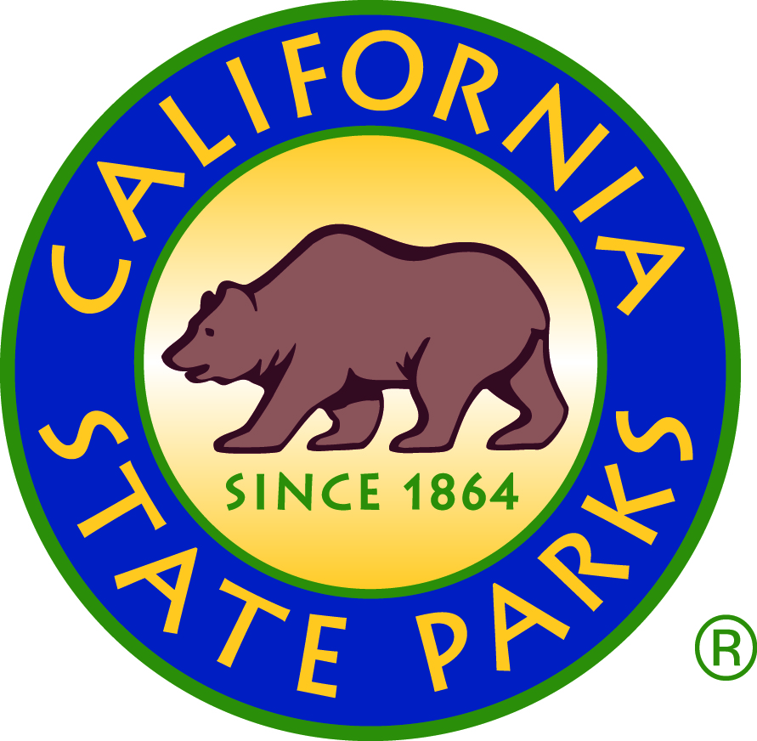

State of California
Natural Resources Agency
Department of Parks and Recreation
Office of Grants and Local Services
“Creating Community through People, Parks, and Programs”
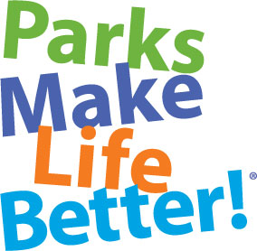

Send Applications and Correspondence to:
Street Address for Overnight Mail:
Calif. Dept. of Parks and Recreation
Office of Grants and Local Services
1416 Ninth Street, Room 918
Sacramento, CA 95814
Phone: (916) 653-7423
Website: www.parks.ca.gov/grants
Please Email Questions for this Program to: National.Program@parks.ca.gov

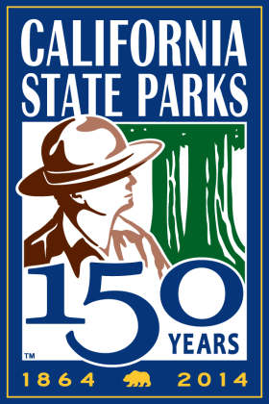

Department Mission

The mission of the California Department of Parks and Recreation is to provide for the health, inspiration, and education of the people of California by helping to preserve the state’s extraordinary biological diversity, protecting its most valued natural and cultural resources, and creating opportunities for high-quality outdoor recreation.

The Office of Grants and Local Services (OGALS) Mission Statement

The mission of the Office of Grants and Local Services is to address California’s diverse recreational, cultural and historical resource needs by developing grant programs, administering funds, offering technical assistance, building partnerships, and providing leadership through quality customer service.

OGALS Vision Goals

- Proactive in meeting California’s park and recreation needs through innovative grant programs and customer service.

- Committed to providing quality customer service in every interaction and transaction as honest, knowledgeable, and experienced grant administrators.

- Sensitive to local concerns while mindful of prevailing laws, rules, and regulations.

- Responsive to the needs of applicants, grantees, nonprofit organizations, local governments, and legislative members, who are our partners working to improve the quality of life for all Californians by creating new parks and recreation opportunities.

TABLE OF CONTENTS

Outdoor Recreation Legacy Partnership Program Overview 4
Process and Timeline 6
Application Packet Requirements 7
Section 1: Application Summary Criteria 8
Section 2: NPS Evaluation Criteria 11
Section 3: Site Map 20
Section 4: Site Photos 21
Section 5: SCORP Priorities for California 22

2016 Outdoor Recreation Legacy Partnership Program

$15 Million New National Competitive Park Program

On March 9, 2016, the National Park Service (NPS) released guidelines for a new $15 million nationwide “pilot program”. NPS invites all states to nominate up to two projects by May 20, 2016.

Therefore, applications must be postmarked by Friday, April 15, 2016. See the “Process and Timeline on page 6 for more information.

National Program Overview:
OGALS will review statewide applications, and can recommend up to two applications for projects that include these objectives:
- Acquisition or development to create a new park or new outdoor recreation opportunity in an economically disadvantaged community that is underserved in terms of parks and recreation resources.
- Project is located in an “urbanized area” with a jurisdiction of 50,000 or more people per the 2010 Census Bureau report.
- Project design results from residents’ input and community based planning.
- Leverages resources through private and public partnerships.
- Project will be completed within three years (Spring 2019) or earlier.

Application Packet: Only four items are required:
- Application Summary Criteria
- NPS Evaluation Criteria
- Site Maps
- Site Photos

Eligible Applicants:
Same as the Land and Water Conservation Fund (LWCF) program:

- Cities and Counties
- Federally recognized Native American tribes
- Recreation and park districts to acquire, operate, and maintain public park and recreation areas
- State Agencies
- Joint Powers Authorities where all members are public agencies

Amount Available: $15 million nation-wide. At least 20 projects will be funded nationally.

- Maximum grant request is $750,000 per application.
- Minimum grant request is $250,000 per application.

Match Requirement:
- At least 50% of the total project cost must be match. The grant can fund up to 50% of the total project cost. The match rules are the same as LWCF.

Administrative Rules: Same as LWCF, if NPS selects the project for funding.

Questions:

For projects in Central and Northern State Counties (Monterey, Kings, Tulare, Inyo Counties and all counties north), email Noelle.Nichols@parks.ca.gov

For projects in Southern Californian Counties (San Luis Obispo, Kern, San Bernardino Counties and all counties south, email Xochi.Prock@parks.ca.gov

The next page provides the process and timeline.

Process and Timeline

March 9, 2016: National Park Service (NPS) released the “Announcement of Federal Funding Opportunity” and guidelines for the new $15 million national competitive “Outdoor Recreation Legacy Partnership Program.”

March 16, 2016: Office of Grants and Local Services (OGALS) issues statewide notification of funding opportunity and application guidelines to over 1,000 Californian agencies.

March 17 through April 14, 2016: Eligible applicants prepare application (narrative, site photos, and map)

April 15, 2016: Application Deadline

- Send the application (narrative, site photos, and map) to OGALS.
- Applications must be sent to OGALS by overnight mail (postmarked) by
April 15, 2016 at:

Calif. Dept. of Parks and Recreation
Office of Grants and Local Services
1416 Ninth Street, Room 918
Sacramento, CA 95814
Attn: National Program

April 18 through May 19, 2016: OGALS reviews all statewide applications and selects two highest ranking applications. Each state can recommend up to two applications.

May 20, 2016: Deadline for OGALS to recommend two applications to NPS.

May 20 through September 2016: NPS reviews up to 100 recommended nation-wide applications (up to two per state).

- NPS can award at least 20 projects amongst all states because $750,000 is the maximum grant amount, and $15 million is available nationwide.
- NPS anticipates initial selection of projects in September 2016.

October 2016 through August 2017: The selected nationwide projects complete the next phase of the application (such as the Proposal Description and Environmental Screening Form (PD/ESF) and Section 106.

Spring 2019: Project must be completed.

Application Packet Requirements

By April 15, 2016, the following four items must be received by OGALS sent by overnight mail (postmarked) to:

Calif. Dept. of Parks and Recreation
Office of Grants and Local Services
1416 Ninth Street, Room 918
Sacramento, CA 95814
Attn: National Program

Provide the four application packet items in the following order:

Section 1: Application Summary Criteria
The summary identifies the applicant, project site address, and criteria for initial statewide ranking.

- See page 8 for instructions

Section 2: NPS Evaluation Criteria
These criteria are provided by NPS. NPS will use the narrative responses to rank all nationwide recommended applications.

Use the same section titles and outline provided in the following pages to structure your narrative:

Part One: Project Narrative (10 pages target length)
- See page 11 for the outline and instructions

Part Two: Budget Narrative (3-4 pages target length, including tables)
- See page 17 for the outline and instructions

Section 3: Site MapS

Section 4: Site Photos

Section 1: Application Summary Criteria

Provide the Summary in the following outline format:

Applicant:
Project Name:
Project Address:
Grant Request Amount:
Applicant’s Grant Administration Contact Information:
(name, email, phone, mailing address)

Criteria Summary

Criteria #1 through #5 add up to 60 points and will be used for preliminary statewide scoring.

- Unmet Need and Project Benefits
Describe the need for and benefits of the acquisition or development project by answering A and B below (Only discuss the phase funded by the grant request and match):

- Need: Why is the project a high priority to serve neighborhood residents by creating a new outdoor recreation opportunity that is currently not available within the project’s ½ mile radius? (Limit the “A. Need” response to one page.)
- Benefits: Describe how the project meets one or more priorities of California’s 2015 Statewide Comprehensive Outdoor Recreation Plan (SCORP) listed on page 22. (Limit the “B. Benefits” response to one page.)

The scale below shows that 20 points will be given to high priority projects.
20-15 | This project meets a high priority and provides significant benefits compared to other statewide applications.
14-10 | This project is an above average priority or provides average benefits compared to other statewide applications.
9-1 | There is no significant effect on the area or neighborhood residents if this opportunity(s) will be unavailable over the next five years compared to other proposed statewide applications, or this proposed recreation opportunity is already available within the ½ mile radius.
0 | No response

- Type of Project
Use the following format to identify the type of project by checking the appropriate field below based on what will be accomplished with the grant and match.
Type of project | Check appropriate field | Points
Acquisition to create a new park | □ | 10
Development to create a new park | □ | 8
Acquisition to expand an existing park | □ | 6
Development to improve an existing park | □ | 4
A maximum of 10 points will be given to acquisition projects for the creation of a new park.
3. Acreage placed under new 6(f)(3) protection
Provide information about the amount of park acreage that will be placed under 6(f)(3) protection, and is not currently under 6(f)(3) protection, if the grant is awarded by using the chart below:
Park acreage already under federal 6(f)(3) protection will not be considered in this criterion (meaning do not report/count the protected acreage as part of the response).

Acreage to be placed under new 6(f)(3) protection

The scale below shows that up to 10 points will be given to projects where land is not currently already under 6(f)(3) protection.

Points

10 | The project site is currently not under 6(f)(3) protection, and if awarded a grant, acreage will be placed under new 6(f)(3) protection
0 | The entire park is already under 6(f)(3) protection, or no information provided

Note: California’s 2015 SCORP includes a priority of placing land under 6(f)(3) protection.

4. Population Density
Use the LWCF Fact Finder available at www.parks.ca.gov/grants to identify the total population within the ½ mile radius of the project site. While the radius starting point can be located anywhere within the park, the push-pin starting the radius must be located in or at least on the park boundary. (The push-pin starting point cannot be outside the park boundary).

Fact Finder Population – Based on ½ mile radius of project site

The scale below shows that up to 10 points will be given to projects having the highest population within the ½ mile radius of the project site.

10 | Highest 30% on the ranked statewide list
6 | From 31% to 70% on the ranked list
3 | From 71% to 100% on the ranked list
0 | No information provided

5. Underserved Population
Provide information about the underserved population by providing the per capita income from the same LWCF Fact Finder Report used for Project Selection Criteria #4.

Per Capita Income of the ½ mile radius of the project site

The scale below shows that up to 10 points will be given to projects in areas having the lowest per capita income compared with all statewide applications.

10 | Lowest 30% on the ranked statewide list
6 | From 31%-70% on the ranked list
3 | From 71%-100% on the ranked list
0 | No information provided

Section 2: NPS EVALUATION CRITERIA

This narrative provides the “sponsor” (which means the “applicant”) the opportunity to describe the purpose of their project and how it meets the objectives of the competition; intended outcomes of the project; and expected benefits (short and long term) and other impacts in terms of improving recreation opportunities that meet an identified recreational deficiency or need for a neighborhood or community.

This Narrative section was developed by NPS. Therefore, some of the terms used may be slightly different than the terms used in the CA State Parks “LWCF Application Guide for Local Agencies.”

NPS’ Evaluation Criteria outlined below includes:

- Project Narrative: Target length is 10 pages
- Budget Narrative: Target length is 3-4 pages, including tables

Format the response using the heading outline and order in bold font below.

Project Narrative

(Target Length: 10 pages)

Project Overview
For acquisition projects, provide a street address, a description of the property, the reason(s)/need for the acquisition, and the number of acres to be acquired.
- Explain whether the acquisition creates a new public park or recreation area or expands an existing site.
- Describe and quantify the types of resources and features on the site (e.g., 50 acres of forested area, 2,000 feet of waterfront, scenic views, vacant lot, special habitats, unique or special features, recreation amenities, historic/cultural resources) as well as any constraints (e.g., hazardous materials/contamination history, restrictions, institutional controls, easements, rights-of-way, reversionary interests, above ground/underground utilities, etc.).
- Describe the plans for the site’s development for recreation purposes and the timeframe, including when the site will be made open and accessible for public outdoor recreation uses.
- Describe the current status of the acquisition, including negotiations with the landowner, completion of due diligence (title work, appraisals).

For development projects, provide a street address, the reason(s)/need for the development and a description of the physical improvements and/or facilities that will be developed with LWCF assistance.
- Explain whether the project involves new development, rehabilitation, and/or replacement of existing facilities.
- Describe and quantify the types of resources and features on the site as well as any constraints.
- Describe the timeframe for completing the project, and when site will be opened (or reopened) and accessible for public outdoor recreation uses.
- In addition, include a site sketch depicting improvements, where and how the public will access the site, parking, etc.

For projects that will comprise acquisition and development, provide a narrative that combines the elements above.

Improving physical and recreational access and addressing recreational deficiencies:

Describe how the proposed project will create or significantly improve access to close-to-home park and recreation opportunities by expanding the quantity or quality of parks or other outdoor recreation areas. This can be through either: creating a new park/outdoor recreational area or significantly enhancing the quality of an existing park/outdoor recreation area by replacing or upgrading infrastructure to be able to provide high priority recreation services. Describe the new or expanded types of outdoor recreation opportunities and/or capacities that will be created as a result of the acquisition and/or development. Describe how the project meets an identified recreational need or deficiency.

20 points:

This criterion will assess the degree to which the proposed project will create or significantly enhance access to close to home park and recreation opportunities by expanding the quantity or quality of parks or other outdoor recreation areas by either: creating a new park/outdoor recreational area or significantly enhancing the quality of an existing park/outdoor recreation area by upgrading the infrastructure to be able to provide high priority recreation services.

Priority will be given to projects located in 1) densely settled neighborhoods or communities that lack any other or adequate parks/outdoor recreation areas within a reasonable service area (i.e, within .5 miles or a 10-minute walk for a neighborhood park, or within 1 mile for a park serving multiple neighborhoods or a community); or 2) whose existing park/outdoor recreation areas are not of a comparable caliber to park/recreation areas elsewhere in the jurisdiction; or 3) whose park/recreation areas are otherwise inadequate to serve community needs.

Improving recreation service to priority target groups for this competition:

Describe the activities and uses planned for the project site after acquisition and/or development.

Describe who will benefit from the project, particularly with respect to the groups targeted by this competition (minorities, youth, and/or low to moderate income individuals or families) and for whom serious recreation deficiencies exist.

Sponsors are encouraged to include available data/statistics about the local populations to be served by the park/recreation area in the response. Census-defined minorities are African-Americans, Hispanics, American Indians, Asians, Eskimos, Aleuts, and Pacific Islanders.

20 points:

This criterion will assess the degree to which the project will improve outdoor recreational opportunities for the target groups (minorities, youth, and/or low to moderate income individuals or families) for whom serious recreation deficiencies exist.

Priority will be given to projects located where they will serve neighborhoods with significant populations of the target groups that are lacking in recreation opportunities. Applicant responses are encouraged to include available data/statistics about the local populations to be served by the park/recreation area. Merit panels will also be provided with relevant Census data. Census-defined minorities are African-Americans, Hispanics, American Indians, Asians, Eskimos, Aleuts, and Pacific Islanders.

Project Engagement and Participation:

Describe the process that led to the development of this proposal. In particular, focus on efforts to engage the public, especially the local community that will be served by the park, and their participation in the project as well as that of other interested/affected entities. Describe any partnerships or other collaborative efforts, such as with neighborhood groups, community organizations, or private entities that have helped facilitate the project. Also, describe or provide evidence of local support for the project, particularly from local residents.

Supporting details could include how the public was notified of and provided opportunity to be involved in planning for and development of the project proposal; who has been involved (including local, state, and federal agency professionals; subject matter experts; and private organizations) and how were they able to help develop or review the proposal; and formal public participation processes such as meetings, hearings, and

comment periods, including dates and length of time provided for the public to participate in the planning process and/or to provide comments.

10 points:

This criterion will assess the level and degree of partnership building in support of the project among members of the public (particularly residents that would be served by the park and neighborhood groups), local government(s), and the private sector (including community organizations and businesses). In particular, the panel will evaluate the extent to which the project was developed with neighborhood and/or community participation, input, and engagement, especially through or with the assistance of private organizations.

Priority will be given to projects that can demonstrate that there has been and continues to be a deliberate initiative or effort by the project sponsor and/or its partner(s) to engage residents of the target neighborhood(s) in the project’s development. Further, where there is a substantial level of collaboration among the public and private sectors, including multiple levels of government, private/non-profit organizations, and community groups.

Innovation and Transformative Attributes:

Describe the extent to which the project encompasses or exhibits innovation, especially in ways that can be transformative for the neighborhood(s) and community in terms of revitalization. These qualities could be related to aspects such as: redevelopment of a blighted or distressed properties; involvement of new or non-traditional partners; unusual features in the project design; employment of novel solutions to issues in/challenges to addressing the community’s recreation needs; the ability to affect or advance other complementary and intrinsic benefits beyond providing new or enhancing park or other outdoor recreation spaces; and other similar characteristics.

10 points:

This criterion will assess the degree to which the project encompasses or exhibits innovation, especially in ways that can be transformative for the neighborhood(s) and community in terms of revitalization. These qualities could be related to aspects such as: redevelopment of a blighted or distressed properties; involvement of new or non-traditional partners; unusual features in the project design; employment of novel solutions to issues in/challenges to addressing the community’s recreation needs; the ability to affect or advance other complementary and intrinsic benefits beyond providing new or enhancing park or other outdoor recreation spaces; and other similar characteristics.

This is a somewhat open-ended criterion but is an opportunity for project sponsors to describe and promote features of the project that go above and beyond the recreation services or opportunities the project will provide. Priority will be given to projects that demonstrate unique features that make them stand out relative to the other proposals submitted for the competition as well as the “typical” LWCF project.

Project’s Alignment with SCORP and other applicable plans:

Describe how the project will advance, implement, or meet a priority need and/or goal of the applicable state’s SCORP and other relevant park and recreation planning documents. Projects can also receive credit for aligning with or advancing priorities of other comprehensive or master plans at the city, regional, and/or state level such as community revitalization plans, economic development plans, open space plans, etc.; and/or benefitting other initiatives and programs.

5 points:

This criterion will assess the degree to which the project advances or is otherwise tied to the priority needs and/or goals of the applicable state’s SCORP and other relevant park and recreation plans. Projects can also receive credit for aligning with or advancing priorities of other comprehensive or master plans at the city, regional, and/or state level such as community revitalization, economic development, or open space plans.

Priority will be given to projects that meet clearly identified goals and/or needs in the SCORP, particularly any that are specific to urban areas, together with other applicable planning documents at different levels of government and/or private sector initiatives.

Project Readiness:

Describe the status of the planning for the grant project and its readiness to be implemented. Provide a narrative description of the timeline for the planned scope of work and a proposed period of performance, including providing dates for discrete benchmarks of significant work elements that will support the grant project’ implementation to completion.

Describe the current use (if any) or disposition of the property targeted for the project. If there are any existing non-outdoor recreation or other non-public uses that are intended to continue on the property on an interim or permanent basis and/or proposed in the future, these should be explained.

5 points:

This criterion will assess the status of the project to evaluate the readiness to be implemented, the likelihood of successful execution, and the viability of the period of performance for the project’s execution.

Priority will be given to projects that are well into or mostly done with the planning stages such that implementation can likely begin within one year and the project could be opened to the public within 2 to 3 years.

Applicant and Partner Capacity:

Describe the project sponsor’s experience in completing other similar park and recreation projects. If partners are or will be involved in the grant project’s implementation, their role(s) should also be described. Describe who holds or will hold title to the property and how the park or recreation area will be managed and maintained to assure permanent use for public outdoor recreation. Describe the funding resources available to support the operation and maintenance. If partners will be involved with long-term management of the property, this should be described. Also describe the project sponsor’s or partner’s past experience, if any, with managing grant funds, particularly LWCF or other federal awards.

5 points:

This criterion will assess the ability and likelihood of the project sponsor and partner(s) (if applicable) to initiate and successfully complete the project as well as effectively manage and sustain the park or recreation area to ensure long-term viability, particularly in the context of LWCF requirements. Also, assesses the project sponsor and/or partner’s demonstrated capacity for appropriate grant management and successful compliance with grant conditions, particularly with past LWCF and/or other federal grants (if applicable).

Priority will be given to projects where the sponsor and/or partner(s) have experience with federal grants and have successfully completed similar projects with no problems complying with grant regulations or program-specific terms and conditions; and where there appears to be capacity for successful long term park management and protection. If the sponsor is a past LWCF grant recipient, the sponsor does not have any known outstanding Section 6(f)(3) conversion issues that are not in the process of resolution.

Budget Narrative

(Target length: 3-4 pages, including tables)

Viability and reasonableness of the project’s budget:

This section should explain how the requested LWCF assistance will be used and how the match requirement will be met, including any costs proposed for overmatch. Break down, describe, and justify the proposed project costs that correspond to the details of the work activities outlined in the project narrative. Project sponsors are encouraged to provide budget information in both narrative and tabular forms to ensure sufficient detail so the budget can be clearly understood, particularly in terms of what costs are proposed for reimbursement by the LWCF ORLP grant and what costs will be used to satisfy the 1:1 match.

Project sponsors are encouraged to review Chapters 3 and 5 of the LWCF Manual to ensure understanding about eligible costs. Of note: Land acquisition costs should be based on appraised value or other estimate of fair market value. Acquisition-related support costs (e.g., appraisals) are not eligible LWCF expenses or as match. On the development side, for this competition, project management/administration expenses, design/engineering fees, and contingencies may be included in the budget, but they are capped at 5% (administration) and 10% (design/engineering and contingencies) of the total budget, respectively. If indirect costs are planned (by the State lead agency) this should be reflected in the budget.

Match contributions can consist of cash, land donation, and in-kind contributions of supplies or services needed to implement the project. Describe the availability or firmness of commitments for funds to meet the 1:1 match and for the full amount of funds needed to complete the project, including any match commitment(s) that exceed the 1:1 requirement. Note that, at a minimum, sufficient funding to meet the 1:1 match requirement must be in hand or firmly committed. If the project match exceeds the 1:1 requirement, indicate how the additional funds/in-kind contributions will be used. Overmatch costs needn’t necessarily be eligible for LWCF but more weight will be given for leveraging if they are. Project sponsors should also ensure costs are reasonable and that it’s clear why they are being included in the project budget.

As noted in Section C.2, other federal resources may not be used as a match for the LWCF grant unless such treatment is specifically authorized the source’s enabling legislation. Project sponsors should be prepared to show supporting documentation if requested. Due to the increase in the ceiling for the LWCF-ORLP request for this competition round, project sponsors will not be permitted to also include LWCF formula funding in the project budget.

If the LWCF ORLP grant-funded project is part of a larger project, please be sure the LWCF-related components of the budget can be clearly discerned. It can be difficult to review and score a budget when it’s not clear how the grant funds will fit in, and project sponsors risk having the requested federal share reduced if it appears ineligible costs will be charged to the grant or as part of the 1:1 match share. Note that the LWCF ORLP and match funded element(s) of the project must still result in a viable recreation opportunity that is not reliant on other funding even in the context of a larger planned project.

10 points:

This criterion will assess the eligibility and reasonableness of the costs included in the project’s budget, whether the budget seems realistic for the scope of work, and the availability of or firmness of commitments for the full amount of funds needed to complete the project, including any match commitment(s) that exceed the 1:1 requirement.

Priority will be given to project proposals with clear and detailed budgets that contain all or mostly LWCF-eligible cost items that are reasonable and obviously related to the scope of the work for which the grant funds are specifically being requested. Priority will also be given to projects where funding to cover the entire project budget is mostly in place (excluding the grant amount), particularly any amounts promised as overmatch.

Partner Support and Leveraging:

Describe the how project is or will be supported by partnerships with the public, private, and/or non-profit sectors specifically through contributions of money, land, supplies, services, etc.

In addition to the types of contributions and amounts, be sure to describe the source(s) of the contributions proposed for the match, particularly if they are from non-public partners in the project, and whether they are already available or still being secured.

If applicable, describe how and to what extent the LWCF ORLP grant will play a role in leveraging funding for the project from non-federal public, private, and/or non-profit resources, and if they allow the project budget to exceed the 1:1 match requirement. Projects that leverage the LWCF ORLP grant funds beyond the 1:1 match will be favored, but more points will be awarded when the leverage is comprised of LWCF-eligible costs directly related to the acquisition or construction work versus other kinds

of costs that support the project in a larger sense but aren’t necessarily needed to support the acquisition or development.

15 points:

This criterion will assess the degree to which the project is or will be supported by partnerships with the public, private, and/or non-profit sectors through contributions of money, land, supplies, services, etc., and the extent of financial leveraging of the federal share with non-federal public, private, and/or non-profit resources that allow the project budget to exceed the 1:1 match required by the LWCF Act.

Priority will be given to projects involving multiple and diverse partnerships that have resulted in contributions of financial resources, particularly non-public resources; and that exceed the minimum 1:1 match level primarily with LWCF-eligible costs.

Section 3: Site Map

Provide the following:

- Fact Finder Report used for the response to Criteria Summary #4 and #5 on page 10 of these guidelines (showing the ½ mile radius of the project site);

- A neighborhood/community map showing the general location of the project and any existing recreation resources adjacent to the project site;

- A map or aerial photo clearly delineating the specific project site to be acquired and/or developed, including the proposed boundary area of the project as required by LWCF Section 6(f)(3).

Section 4: Site Photos

- Provide up to four 8 ½” x 11” sheets filled with photos of the project site and its surrounding area.
- Provide a very brief description of what is in each of the photos. Adding the direction of the view noted with each photo as “looking north, south, east, or west” is helpful to orientate someone not familiar with the site. Use a point of reference for the direction of the view, such as “from the center of the project site or “from the corner of X and Y Streets.”

New Parks:
For a new park, provide a panoramic picture of the site, and if possible, showing a residential area in the background.

Development in Existing Parks:
If the project includes the development of a new facility in an existing park, provide a picture showing where the new facility will be constructed.

Renovation in Existing Parks:
If the project includes the renovation of an existing facility in an existing park, provide a picture showing the need for renovation (wear/deterioration).

Section 5: SCORP Priorities for california

California’s 2015 SCORP establishes the following priorities that are applicable to this grant program:

- Increase park access for Californians including residents in underserved communities.

- Encourage park development within a half mile of park deficient neighborhoods to provide easier access.
- Utilize federal grants to create new recreational trails and greenways to provide active transportation corridors from neighborhoods to parks, schools, and workplaces.

- Give priority to projects that address unmet park and recreation needs, with emphasis on proposals to:

- Create new parks within a half mile of underserved communities.
- Renovate or create new outdoor facilities within existing parks not currently under 6(f)(3) protection.
- Provide community space for healthy lifestyles, children’s play areas, environmental justice, cultural activities, historic preservation.
- Engage community residents during the project concept and design process.

- Increase the inventory of California Wetlands under federal 6(f)(3) protection that also meets public outdoor recreation needs through the efforts of multiple agencies.

- Create new wetlands where they previously existed and have been destroyed.
- Acquire existing but unprotected wetlands to hold in public trust.
- Restore, where needed, the quality of existing wetlands owned by public agencies.
- LWCF grants for wetlands will include public access for recreation and educational opportunities.

California’s 2015 SCORP is available at www.parks.ca.gov/SCORP

