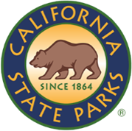
SDC OPEN SPACE

NEWSLETTER

ISSUE NO # 001| MAY 2026
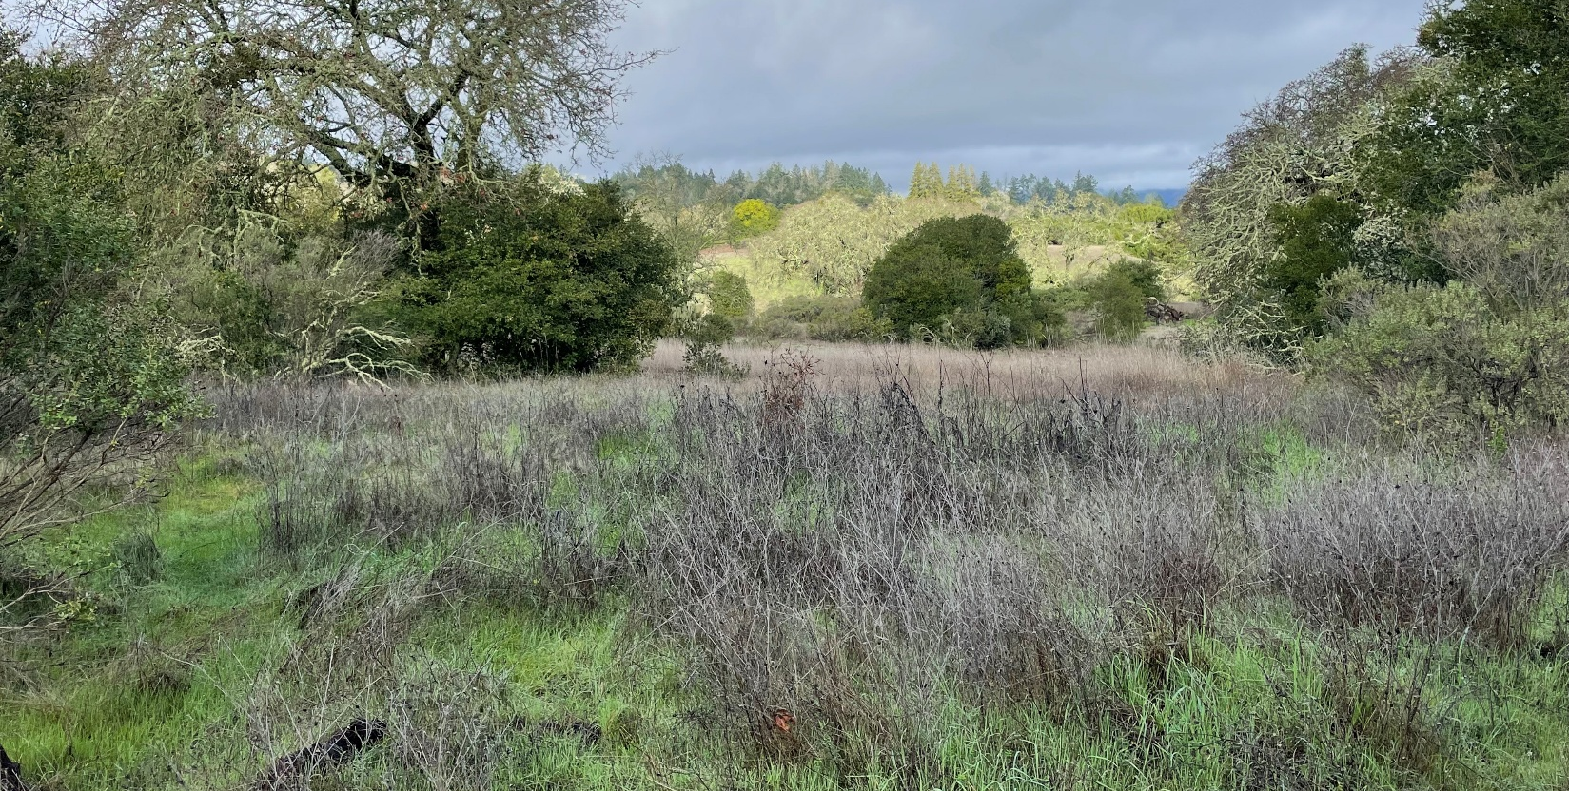
Caption: Wetlands at SDC Open Space. Photo by: Peter Ostroskie, California State Parks

WELCOME!
Thank you for reading our very first issue of the Sonoma Developmental Center Open Space Newsletter, otherwise known as the SDCOS Newsletter.
In this publication, we are bringing you the latest news on the SDC Open Space from us at California State Parks. We plan to release new issues periodically, depending on the frequency of updates. Regardless, our staff are working hard to preserve and enhance the natural beauty and hidden stories of this cherished space.
We hope you enjoy perusing this newsletter!
Carmen Vanni (she/her)
State Park Interpreter I (PI)
Carmen.Vanni@parks.ca.gov
TABLE OF CONTENTS

Featured Article: What is Sonoma Developmental Center Open Space? 4
What is the Cannabis Watershed Protection Program (CWPP)? 6
News & Updates 7
Calendar of Events 8

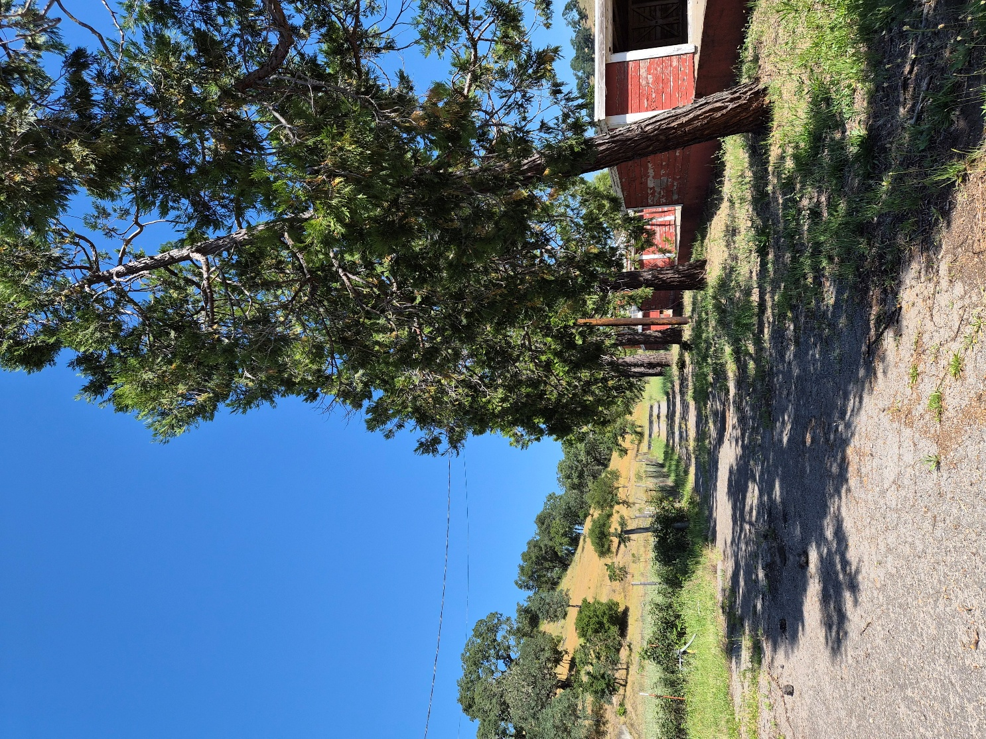
Photo by: Carmen Vanni, California State Parks

Featured Article: What is Sonoma Developmental Center Open Space?
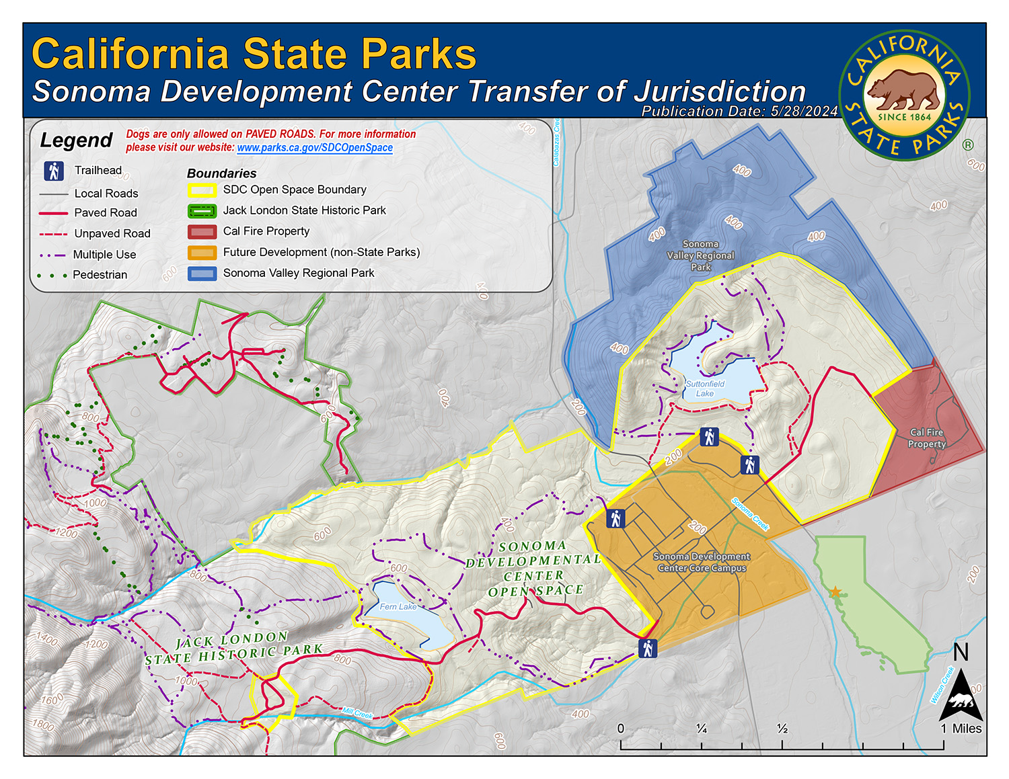
Caption: Sonoma Developmental Center Transfer of Jurisdiction. Photo by: California State Parks
Established in 1891, the Sonoma Developmental Center (SDC) occupies a cherished spot in the Sonoma Valley. Comprising approximately 180 acres of developed campus and 765 acres of natural areas, SDC provided a serene and therapeutic setting for individuals with developmental disabilities. Its extensive trail system and essential water infrastructure, including two reservoirs and a treatment plant, enhanced its significance.
For over a century, SDC offered specialized care, earning national recognition as a healing community. As the valley's primary employer, it fostered deep connections with neighboring communities until its closure in 2018. Despite this, SDC's legacy persists, leaving an enduring mark on the region's history.
On January 1st, 2024, the transfer of approximately 750 acres of open space to California State Parks was finalized, marking the largest land acquisition in the Sonoma Valley since 2010. This new addition to State Parks ensures protection under their mission, with management plans already underway to safeguard and enhance the property.
We at California State Parks are eager to partner with various organizations who have a vested interest in the future of the property. I was invited to our first informal meeting of partners on a beautiful public hike around the property hosted by Tracy Salcedo, Chair of Sonoma Mountain Preservation on Saturday, May 2nd, 2026. Also in attendance was Steve Lee of the Sonoma Ecology Center, Angela Nardo-Morgan of the Glen Ellen Historical Society, and other interested locals. It was a fun and educational networking event. I look forward to next year!
We have two new staff members who have joined the State Parks team to serve the SDC Open Space. First, we have Associate State Archaeologist (PI) Sally Gaston. Sally joined us in late 2025 under the Cultural Resources Division. At SDCOS, she will be surveying, cataloging, and stewarding our cultural resources through research and consultations. Together with Sonoma State University’s Anthropological Resource Center, the Federated Indians of Graton Rancheria, and California State Parks, Sally and the rest of the division will collaborate under the CWPP to create a cultural inventory of the park. This inventory will serve as the basis for new interpretive signage, kiosks, and programming at the SDC.
Likewise, we also have myself, Carmen Vanni, joining as State Park Interpreter I (PI). My role is to collaborate with internal staff and outside partners to foster public relations related to SDC Open Space. In collaboration with Sally Gaston, Daniel Williford of the CWPP, Cultural Resources Supervisor/State Historian III Noah Stewart, and many others, my role is to both communicate the progress of the CWPP project to the public and create educational programming about the cultural and natural resources preserved at SDCOS.

If you have any questions, comments, anecdotes, or suggestions about accessibility regarding SDCOS park land, programming, or communications, please contact us via email at Carmen.Vanni@parks.ca.gov or call the Bay Area District Office at (707)769-5652 | 711, TTY Relay Service.
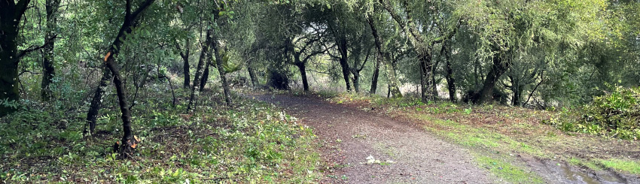

What is the Cannabis Watershed Protection Program (CWPP)?
The Cannabis Watershed Protection Program (CWPP) is a multidisciplinary team dedicated to restoring watersheds affected by illegal cannabis cultivation. State Parks created the program in 2019 with funding from Proposition 64 (The Control, Regulate, and Tax Adult Use of Marijuana Act), to repair the damage done by decades of illicit growing activities throughout California State Parks. Unique to California, this multifaceted team brings a holistic approach to the complex work of protecting parks from cannabis cultivation and restoring degraded watersheds back to their natural state.
In more recent times, remote areas of the SDC Open Space property were damaged by illegal cannabis cultivation. As part of an effort to protect and preserve the local natural and cultural history, State Parks has teamed up with Sonoma State University to conduct a cultural survey to inventory and protect cultural resources within this new acquisition. Insights from this survey will inform future exhibits and educational activities in the park.
For more information on the Cannabis Watershed Protection Program, please go to the CWPP webpage here.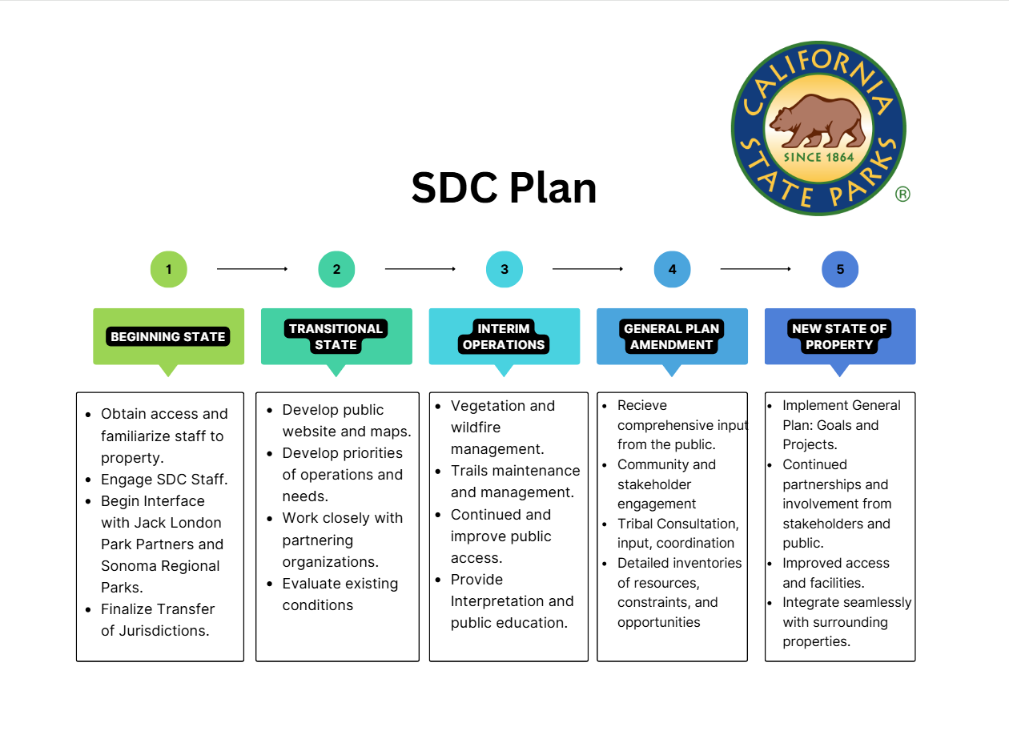

News & Updates

Pile Burning at SDC Open Space – Fern Lake

Starting on April 20th, 2026, California State Parks and CAL FIRE cooperated on a scheduled pile burn at Fern Lake on SDC Open Space property. The burn officially concluded on April 30th, 2026, a bit past the scheduled end date. Read more about the burn on Watch Duty. Thanks to Naftali Moed and Maxwell Psaledakis from the Bay Area District Wildfire & Forest Resilience Program for their hard work in preserving and enriching the park and its future.
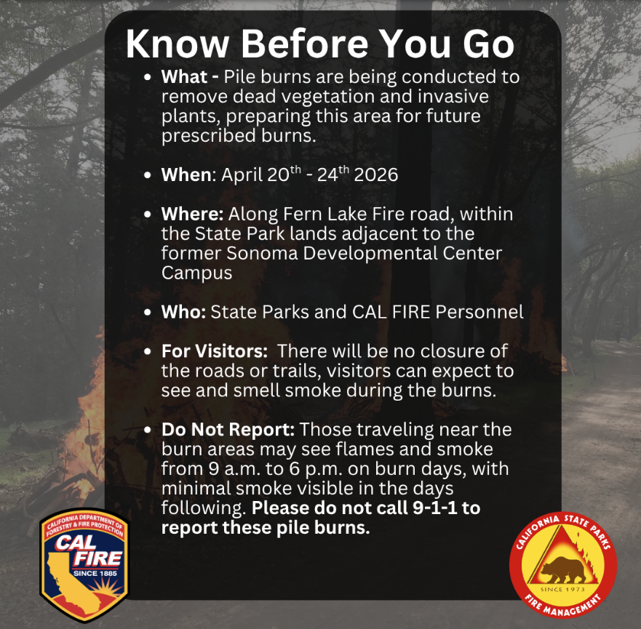

Calendar of Events

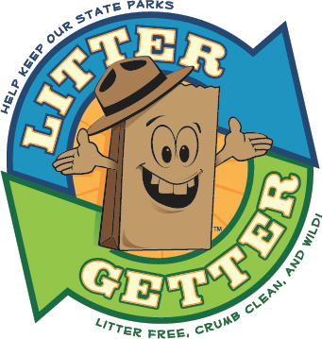
May

Saturday, May 23rd – SDC Open Space Trash Clean Up Day
Tired of seeing trash in the park? Come and join us on Saturday, May 23rd from 10 AM to 12:30 PM for a chance to beautify and protect the SDC Open Space. Meet at the intersection of Harney and Railroad. Gloves, bags, and trash grabbers will be provided. Water, hats, and sturdy shoes are recommended. This event is part of the Litter Getter Program.

Saturday, May 30th – Accessible History Walk

Join us for an accessible history walk and learn about disability history in Sonoma Valley on newly acquired State Park land at the Sonoma Developmental Center Open Space. Meet at the intersection of Harney and Railroad in Eldridge, California at 10 AM. Water, hats, and sturdy shoes are recommended. Walk will be on the Sunrise/Baker Loop on the eastern side of the property. The paved path has light shade and gradual changes in elevation. Walk will last for one hour.
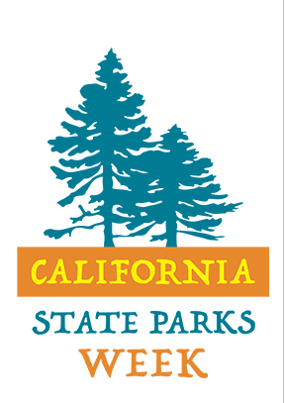

June

June 10th – 14th – California State Parks Week
California State Parks Week is an annual event that celebrates the amazing diversity of California’s State Park System. We invite Californians to celebrate the communities and cultures that make California special! Check out the State Parks Week event calendar here.

CALIFORNIA STATE PARKS SUPPORTS EQUAL ACCESS. PRIOR TO ARRIVAL, VISITORS WITH DISABILITIES WHO NEED ASSISTANCE SHOULD CONTACT CARMEN VANNI AT (707)769-5652.

