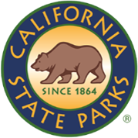
SDC OPEN SPACE

NEWSLETTER

ISSUE NO # 003| JULY 2026
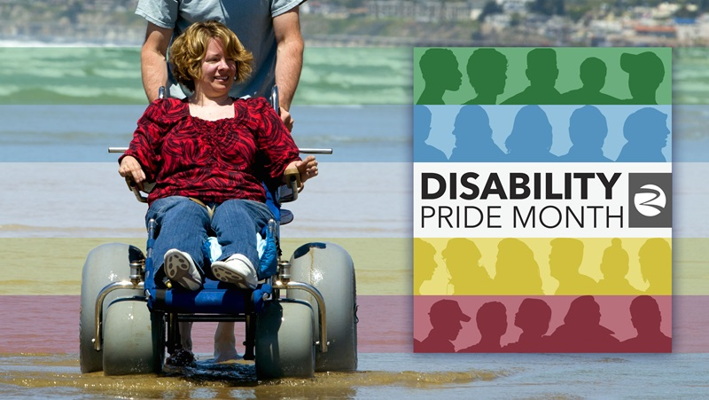
Caption: Person in a beach wheelchair. Photo by: California Natural Resources Agency

WELCOME!
The following message comes from the California Natural Resources Agency.

July is Disability Pride Month, an annual celebration of differing abilities that connects back to the passage of the Americans with Disabilities Act (ADA) of 1990, a ruling prohibiting discrimination against people with disabilities. This is a time to honor and uplift the identities, resilience and contributions of disabled people across our country.
Carmen Vanni (she/her)
State Park Interpreter I (PI)
Carmen.Vanni@parks.ca.gov

TABLE OF CONTENTS

Featured Article: Disability Pride in California State Parks 4
What is the Latest News on the Cannabis Watershed Protection Program (CWPP)? 6
News & Updates 6
Calendar of Events 7

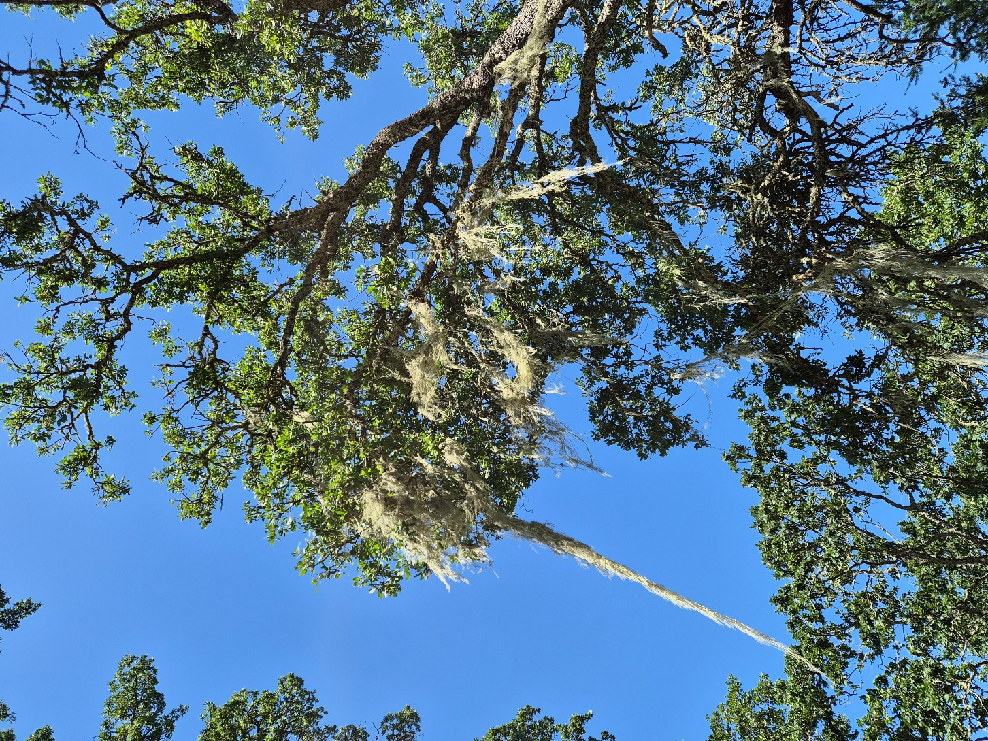
Caption: Oak tree at SDC Open Space. Photo by: Carmen Vanni, California State Parks

Featured Article: Disability Pride in California State Parks

The following article uses information from the California Natural Resources Agency Disability Pride Month page.
Caption: Disability Pride Flag. Photo by: California Natural Resources Agency.
The California Natural Resources Agency, which is the parent agency for the Department of Parks & Recreation, is proud to celebrate Disability Pride Month this July 2026. Disability Pride Month celebrates individuals with differing abilities as well as the landmark passage of the Americans with Disabilities Act (ADA) of 1990. The disability pride flag was created to symbolize the diverse experiences of individuals with disabilities. The flag colors represent the following ideas:
- Red – physical disabilities
- Gold – cognitive and intellectual disabilities
- White – nonvisible and undiagnosed disabilities
- Blue – psychiatric disabilities
- Green – sensory disabilities
- Black – honoring those who have died due to negligence, suicide, rebellion, illness, and eugenics
The agency’s theme this year is “The World Works Better with Us”, a powerful reminder of what disabled people bring to our workspaces, parks, communities, schools, and more. The California Natural Resources Agency is celebrating the month with five special events; three in-person events at their office in Sacramento and two virtual events. You can check the event details here. The California State Parks WordPress blog also has two pieces on accessibility in parks; you can read them here and here.
Do you want to visit our state parks at a reduced cost? See if you qualify for the Disabled Discount Pass, a lifetime pass for individuals with permanent disabilities, entitling the passholder to a 50% discount on vehicle day-use, family camping, and boat-use fees. You can look for parks accepting the pass here. Navigate to the “Open Filter” button to the right of the search bar and check “Disabled Discount Pass”. Applications can be submitted at the Bay Area District Office in Petaluma or online on the state parks website.
Here at Sonoma Developmental Center Open Space, we are celebrating Disability Pride Month by diversifying our guided hike program into two separate programs: an Accessible History Hike and a Lake Suttonfield Guided Hike. These programs will keep occurring after Disability Pride Month is over.
The Accessible History Hike covers the Sunrise/Baker loop, which is a flat, 45 to 50-minute hike around the easternmost side of the property with slight elevation changes and light shade. The loop passes by several pieces of historic infrastructure once used by the SDC such as a farm, a horse corral, the dairy, various maintenance buildings, the sewage treatment plant, and the soccer field to name a few.
The eastern side of the property was mainly used for animal husbandry and facility management, which all contributed to the SDC being a true self-sustaining community for a time. The paved loop acts as a perimeter to a beautiful seasonal wetland. We hope that this hike will be both a welcoming introduction and celebration of disability history and access in California State Parks.
Additionally, while not on an ADA trail, SDCOS interpreters are eager to invite visitors to discover the natural beauty of Lake Suttonfield, a historic man-made reservoir that is now a beloved hiking destination for Sonoma County locals. The trail is about 2.5 miles in length with small elevation changes and is unpaved. While hiking, visitors can expect to see several types of freshwater birds, perching birds, woodpeckers, and birds of prey. There are also a variety of shrubs, wildflowers, aquatic life, bugs, and many more types of flora and fauna to discover.
We want visitors to walk away with a finer understanding of the cultural and natural history of Sonoma Developmental Center Open Space. A major idea we are hoping to explore in the park is “rehabilitation”. How can nature be healing? What opportunities does it offer to communities? How can we learn from the history of the land? These are some of the questions we are asking ourselves as we interpret the property. We hope that through interpretation, visitors will be able to discover the rehabilitative qualities of the SDC Open Space and continue to appreciate the service it provides to the local community.

If you have any questions, comments, anecdotes, or suggestions about accessibility regarding SDCOS park land, programming, or communications, please contact us via email at Carmen.Vanni@parks.ca.gov or call the Bay Area District Office at (707)769-5652 | 711, TTY Relay Service.
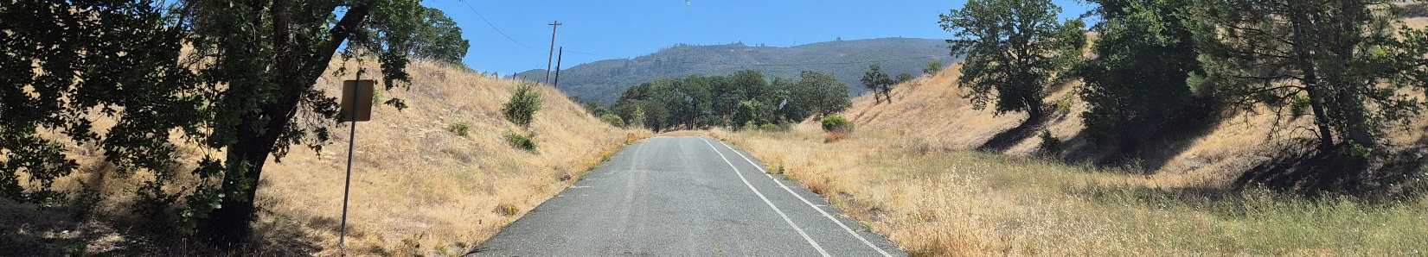
Caption: Sunrise Road. Photo by: Carmen Vanni, California State Parks

What is the Latest News on the Cannabis Watershed Protection Program (CWPP)?
Bay Area District Staff are steadily progressing on the installation of interpretive panels in the property. On Wednesday, July 15th, Bay Area District staff met with interpreters from the CWPP in person at SDCOS to tour the eastern side of the property and discuss potential themes, locations, and accessibility features for the panels. Further meetings will be scheduled to confirm what was discussed in the park.
In other news, the Cannabis Watershed Protection Program has launched “(Re)Turning to the River”, a podcast focused on watershed stories. Episodes are uploaded every two weeks in English and Spanish. You can learn more about the podcast here.

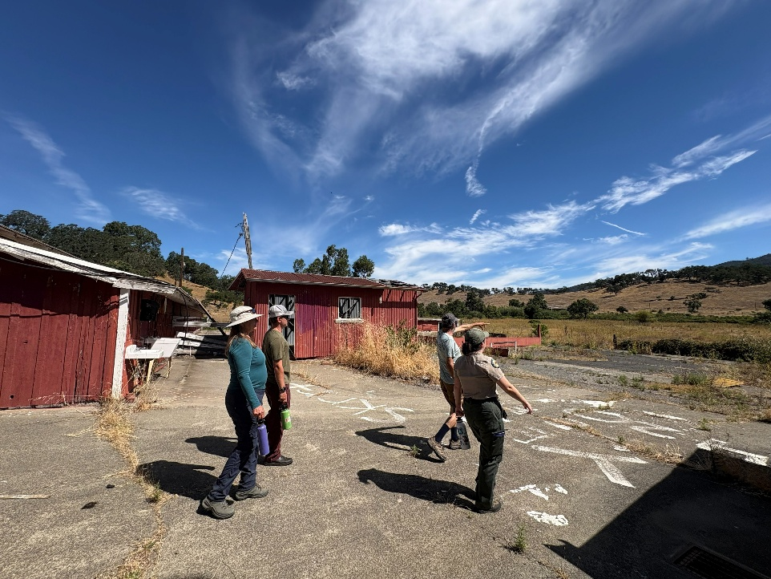
News & Updates
Caption: Hikers at the old farm. Photo by: April Farnham, California State Parks

Bay Area District, Partner, and HQ Staff see SDCOS in Guided Hike
State Park Interpreter I Carmen Vanni was pleasantly surprised to see Bay Area District, Jack London Park Partners, and California State Parks Headquarters Staff attend a guided hike in the park on Saturday, July 11th at 10 AM. The group of 8 explored the Sunrise/Baker loop and visited the historic farm while also learning about our endangered wetlands. After a short break, a smaller group explored the perimeter of Lake Suttonfield and was lucky enough to observe a family of American coots swimming in the lake. The hikers had a wonderful time exploring the eastern side of the SDC Open Space. We hope to see more attend a guided hike in the future!

No Prescribed Burns Planned During Fire Season
The Bay Area District Wildfire & Forest Resilience Program managers have announced that they will be pausing any fire management at SDCOS for the remainder of fire season, usually between the months of June/July and October/November.

Calendar of Events

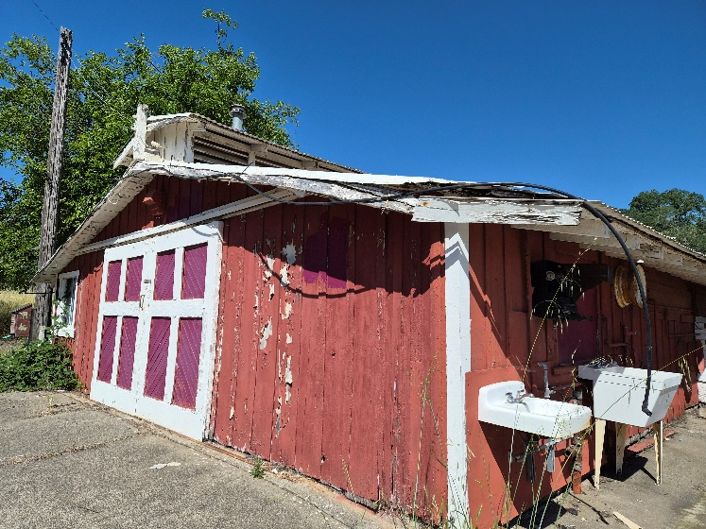
July
Caption: Old farm at SDCOS. Photo by: Carmen Vanni, California State Parks.

Saturday, July 11th & 18th – Accessible History Hike
Celebrate Disability Pride Month by joining us for a beginner-friendly hike on newly acquired State Park land at the Sonoma Developmental Center Open Space! Meet at the intersection of Harney and Railroad in Eldridge, California at 10 AM. Water, hats, and sturdy shoes are recommended. This hike includes ADA accessible trails. Park does not charge for entry.

Saturday, July 25th – “The People of Eldridge” Lecture by E. Breck Parkman
Come and join Breck Parkman at the Sonoma Community Center (Room 110) from 10:30 AM to 11:30 AM to hear a collection of biographies of more than 100 former SDC staff members. Hear firsthand accounts of SDC workers between the 1920s and 1940s!

August

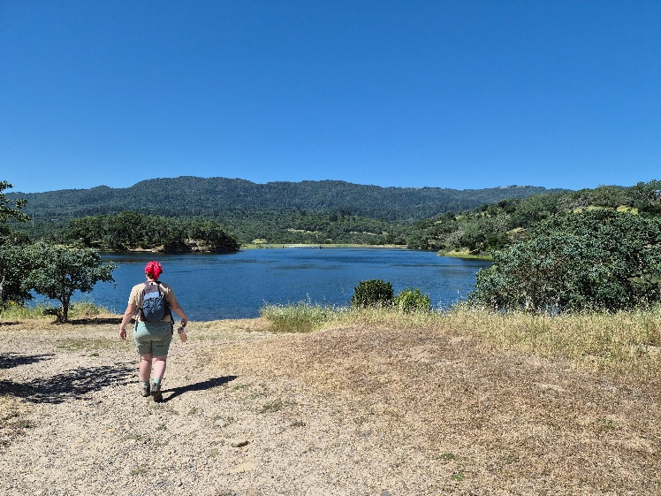
Saturday, August 1st – Accessible History Hike
Caption: Hiker at the top of Lake Suttonfield. Photo by: Carmen Vanni, California State Parks.
See July 11th & 18th event details.

Saturday, August 8th – Lake Suttonfield Guided Hike
Check out the new Sonoma Developmental Center Open Space by hiking around the beautiful Lake Suttonfield! Meet at the intersection of Harney and Railroad in Eldridge, California at 10 AM. Water, hats, and sturdy shoes are recommended. This easy to moderate hike is about 2.5 miles in length on unpaved trail with slight elevation changes. Hike is expected to last about 1.5 hours. Park does not charge for entry.

Saturday, August 8th – Nature & Community Fair
Enjoy an evening of nature and community by visiting over two dozen booths hosted by county, state, and national environmental and community groups in the historic downtown Sonoma plaza! This free event runs from 4:30 PM to 7:30 PM and is family friendly.

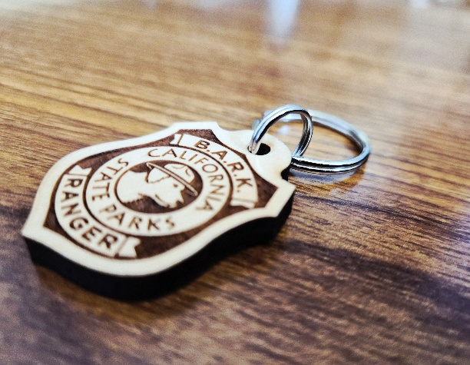
Saturday, August 22nd – B.A.R.K. Ranger Pop-Up
Caption: B.A.R.K. Ranger badge. Photo by: Carmen Vanni, California State Parks.
Do you love walking your dog at your local state park? Check out our B.A.R.K. Ranger pop-up tent at SDCOS on Sunrise/Baker Road from 9 AM to 12 PM and learn how your pup can become a B.A.R.K. Ranger!

September

Saturday, September 12th – SDC Open Space BioBlitz 2026
What species call our park home? Let's explore together! Help us develop a species list for our newest property via iNaturalist! Meet at the intersection of Harney and Railroad at 10 AM on Saturday, September 12th and let’s explore Lake Suttonfield together!
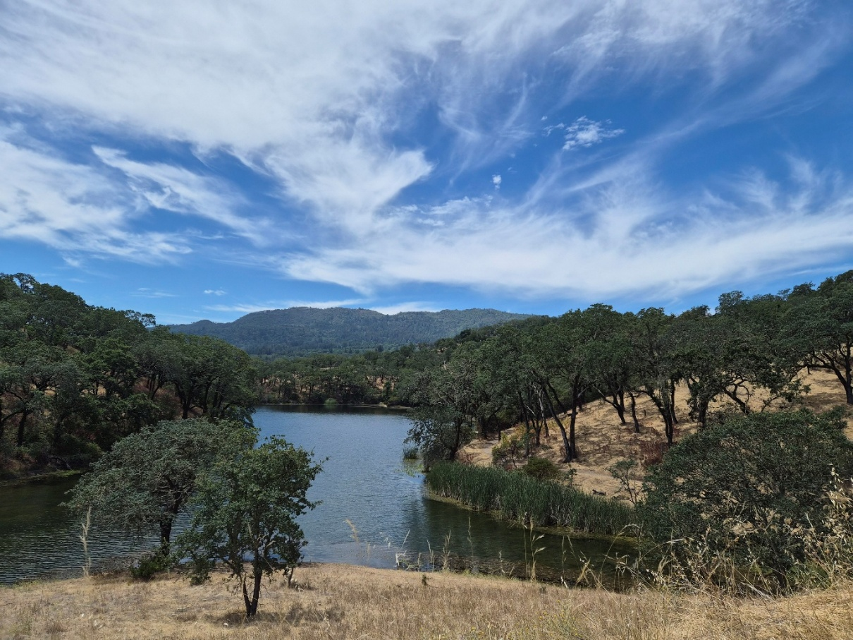
Photo by: Carmen Vanni, California State Parks
CALIFORNIA STATE PARKS SUPPORTS EQUAL ACCESS. PRIOR TO ARRIVAL, VISITORS WITH DISABILITIES WHO NEED ASSISTANCE SHOULD CONTACT CARMEN VANNI AT (707)769-5652.
