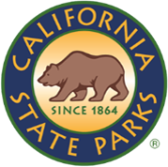
SDC OPEN SPACE

NEWSLETTER

ISSUE NO # 004| AUGUST 2026
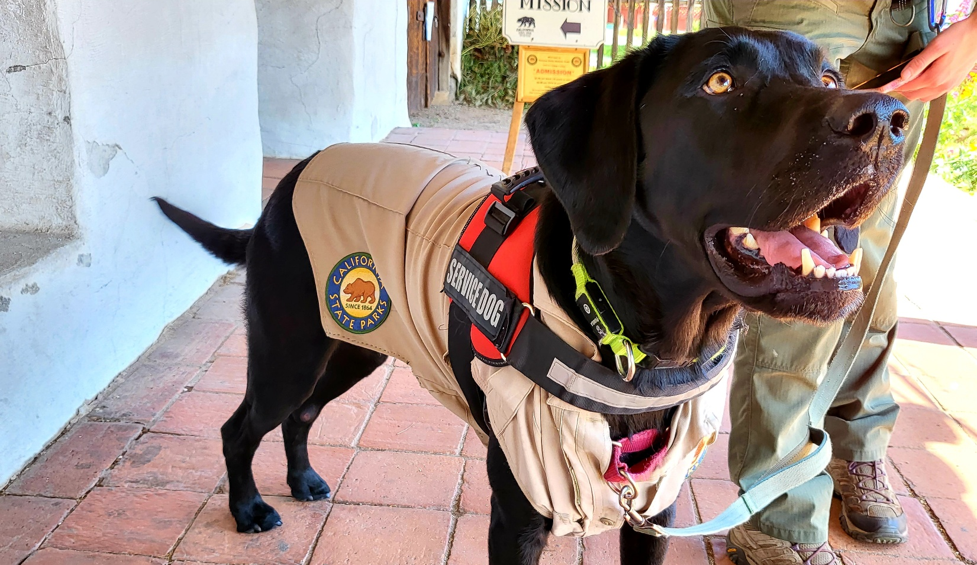
Caption: A service dog with a vest and parks uniform. Photo by: Carmen Vanni, California State Parks.

WELCOME!
Do you love recreating at your local state park with your furry friend? We love it too! In this issue, we will be diving into all the ways dogs and state parks interact with each other. Whether your dog is a family pet or a lifesaving therapeutic partner, we want to ensure both the visitor and the dog are safe in all our public lands.
Carmen Vanni (she/her)
State Park Interpreter I (PI)
Carmen.Vanni@parks.ca.gov
TABLE OF CONTENTS

Featured Article: Dogs, Service Animals, and You at California State Parks 4
What is the Latest News on the Cannabis Watershed Protection Program (CWPP)? 7
News & Updates 8
Calendar of Events 9

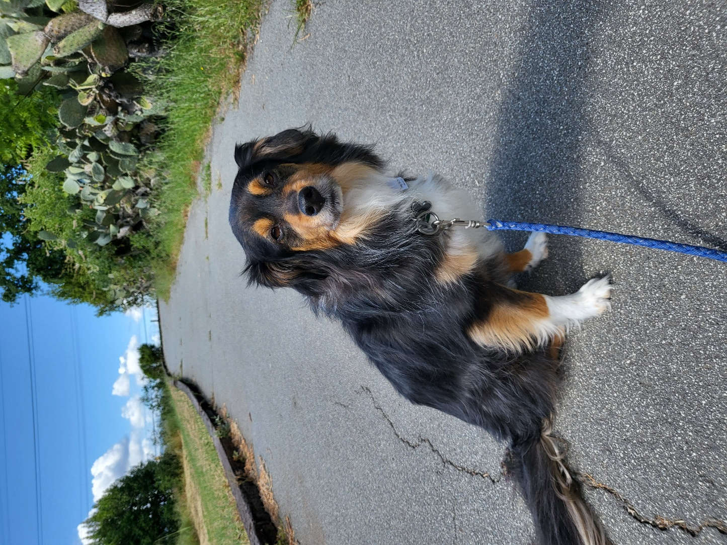
Caption: A dog leashed and on a paved road. Photo by: Carmen Vanni, California State Parks.

Featured Article: Dogs, Service Animals, and You at California State Parks
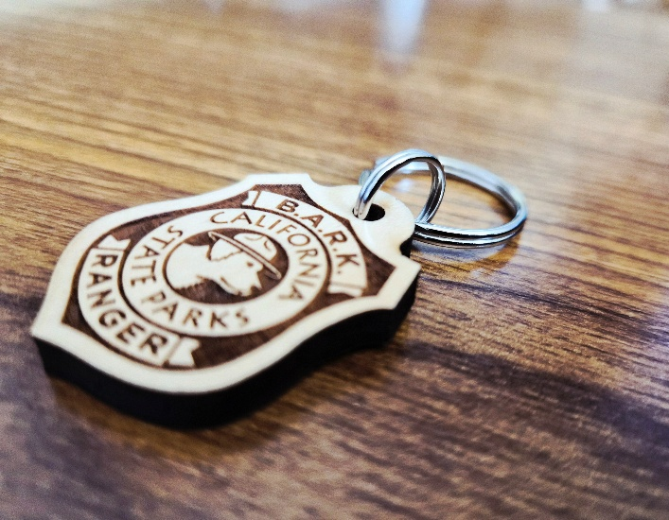
Many of us love to visit our local state parks for various reasons. Perhaps you like to hike or walk in a beautiful natural environment. Or maybe you like taking a tour of a historic site and learning something new. Regardless, while all of us are enjoying our state parks, our dogs are sometimes enjoying them alongside us! But how do we ensure that our dogs, our wildlife, and our fellow park visitors are safely recreating? How can we make sure everyone is getting the most out of their experience while also protecting the landscape?
A wooden B.A.R.K. Ranger badge. Photo by: Carmen Vanni, California State Parks.
California State Parks employs a standard set of rules in all parks regarding dogs or other service animals (more detailed rules can be found on the Visiting State Parks With Your Dog webpage):
- Dogs must always be on a maximum 6-foot leash and physically under your control.
- Vicious or unusually noisy dogs will not be allowed in the park.
- Dogs must not be left unattended.
- Dogs are not allowed on trails, near rivers or creeks, in the open forest and meadows, or in the environmental campsites.
- Remember to clean up after your dog.
- Service animals* are allowed in areas open to the public; however, misrepresenting a dog as a service animal is considered a misdemeanor. (California Penal Code 365.7)
* A service animal is defined as “animals that are individually trained to perform tasks for persons who have qualifying disabilities under ADA. A service animal is any dog (or miniature horse) that is individually trained to do work or perform tasks for the benefit of an individual with a disability, including a physical, sensory, psychiatric, intellectual, or other mental disability.” Visit the Service Animals in State Parks webpage for more information.
Now that we know the basic rules at all state parks, how do they apply at Sonoma Developmental Center Open Space?
The biggest point of confusion for park visitors is knowing which trails are dog-friendly and which aren’t. Because the property is still in its early stages, signage can be hard to come by. Until the proper signage is installed, the next time you approach a trail at SDCOS with your pup, ask yourself this simple question: is this path paved or unpaved? If it is a paved path, such as Sunrise and Baker roads on the east side or Orchard Road on the west side, then your dog IS allowed to enter. If the road is unpaved, such as the hiking trails around Suttonfield and Fern Lakes, your dog IS NOT allowed to enter.
Unpaved trails are a low impact way for responsible park visitors to get personal with nature. We can walk through redwood groves, smell native wildflowers, and witness wildlife in their natural environment. We want to ensure that our natural resources are protected for future generations! When dogs are introduced to that environment, they can jeopardize the health and safety of those resources. One such way is by being a stressful presence for our local wildlife. Dogs are non-native animals and are highly domesticated. Their presence alone is enough to stress out local wildlife. Therefore, we encourage visitors to treat dogs as an extension of their own presence in a park environment. The best motto to remember when visiting a state park is to “Leave No Trace”. Alongside picking up your trash, make sure to keep yourself and your dog on appropriate trails to reduce the impact of your visit.
Another reason dogs are not allowed on unpaved trails is because of the ecological impact to our plant life. Dog urine and feces contain bacteria and/or remnants of their diet. These ingredients are non-native to the area and are therefore risky to introduce to the landscape if left unchecked. Dogs can eat grass as well, which could spread invasive grass via seeds in their stool to protected areas if left alone. Additionally, when dog feces are left behind, disease could spread to local wildlife as well. The damage from these factors adds up if left unchecked and can harm the very environment we wish to save decades down the line. As the saying goes, the best time to plant a tree (or in this case, prevent dogs from harming our park land) was 20 years ago. The next best time is now.
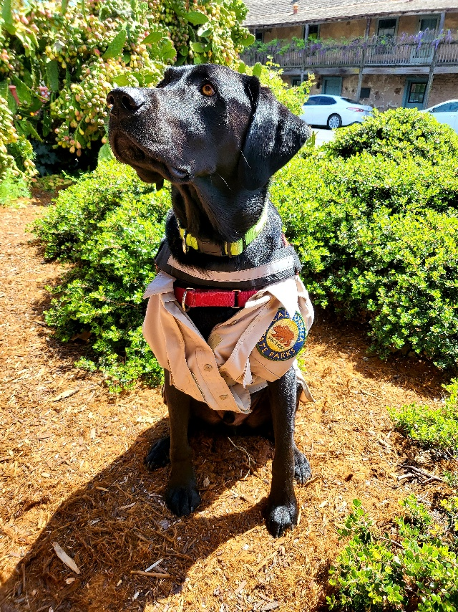
Nature has its own ways it can pose a risk to you and your dog’s health. Even if you believe that you or your dog is not susceptible to these risks, others could be. For example, if you expose your dog to poison oak or ticks and let your dog greet another visitor or furry friend, especially unleashed and out of your control, those risks can spread to others without their consent. Certain plant life, such as foxtails, can invade your dog’s ears or nose and be deadly if left untreated. Some water features, such as lakes, rivers, or creeks, can also contain deadly levels of algae blooms if dogs are exposed to it via swimming or drinking. When recreating, we always want to make sure the park visitor is aware of these potential hazards.
A service dog in a state park uniform. Photo by: Carmen Vanni, California State Parks.
Service animals are a welcome addition to any state park. We want to ensure that all park visitors have the tools they need to safely recreate and engage with the site! California State Parks allows service animals in all public areas. However, park staff are allowed to ask two questions to the visitor if the role of the animal is not clear. Those questions are:
- Is the dog a service animal that is required because of a disability?
- What task or service does the animal provide? (Note: this is not the same as “what is your condition that requires you to have a service animal?”).
If park staff observe that the service animal is out of control of its owner, is not housebroken, and is overall a disturbance to the park environment, the owner will be asked to leave. The ADA does not cover animals providing emotional support, comfort, or a general sense of wellbeing for the individual.
What are some other ways that dogs are welcomed in California State Parks? One answer is the B.A.R.K. Ranger Program! This is a small program that encourages visitors and their dogs to be good stewards to our parks. We ask the visitor and their dog to adhere to the B.A.R.K. rules as follows before recreating:
- Be aware of dog friendly spaces
- Always bag your waste
- Remain on leash
- Keep your distance from wildlife
The dog owner can return after their walk and recite the B.A.R.K. Ranger Oath in front of park staff to complete the program:
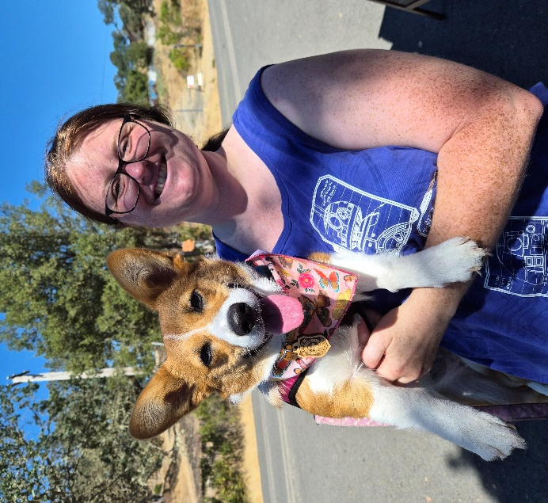
“As a well-behaved dog, I, [dog name], and my human, [owner’s name], promise to respect the rules of B.A.R.K. and to help show others how to care for our State Parks.”
At the end of the program, the dog becomes a B.A.R.K. Ranger, earns a badge, gets a commemorative photo taken as a souvenir, and hopefully inspires other dog walkers to become B.A.R.K. Rangers!

If you have any questions, comments, anecdotes, or suggestions about accessibility regarding SDCOS park land, programming, or communications, please contact us via email at Carmen.Vanni@parks.ca.gov or call the Bay Area District Office at (707)769-5652 | 711, TTY Relay Service.
A dog and her human owner after earning a B.A.R.K. Ranger badge. Photo by: Carmen Vanni, California State Parks.

What is the Latest News on the Cannabis Watershed Protection Program (CWPP)?
The CWPP is acting as inspiration for Interpreters at Sonoma Developmental Center Open Space. As the school year is approaching, it is time to consider what school programming will look like at the park. In-person field trips are unlikely currently due to a lack of signage and maintenance. However, California State Parks has a robust online education program called PORTS, which brings our parks to classrooms near and far via Zoom.
The CWPP has great interpretive tools to educate students on our watersheds. The program launched a PORTS series in 2025, which we are considering using for inspiration in our future PORTS programming. In the meantime, state park Interpreters are in the process of contacting local schools to gauge interest in the program and narrow down the list of potential topics.
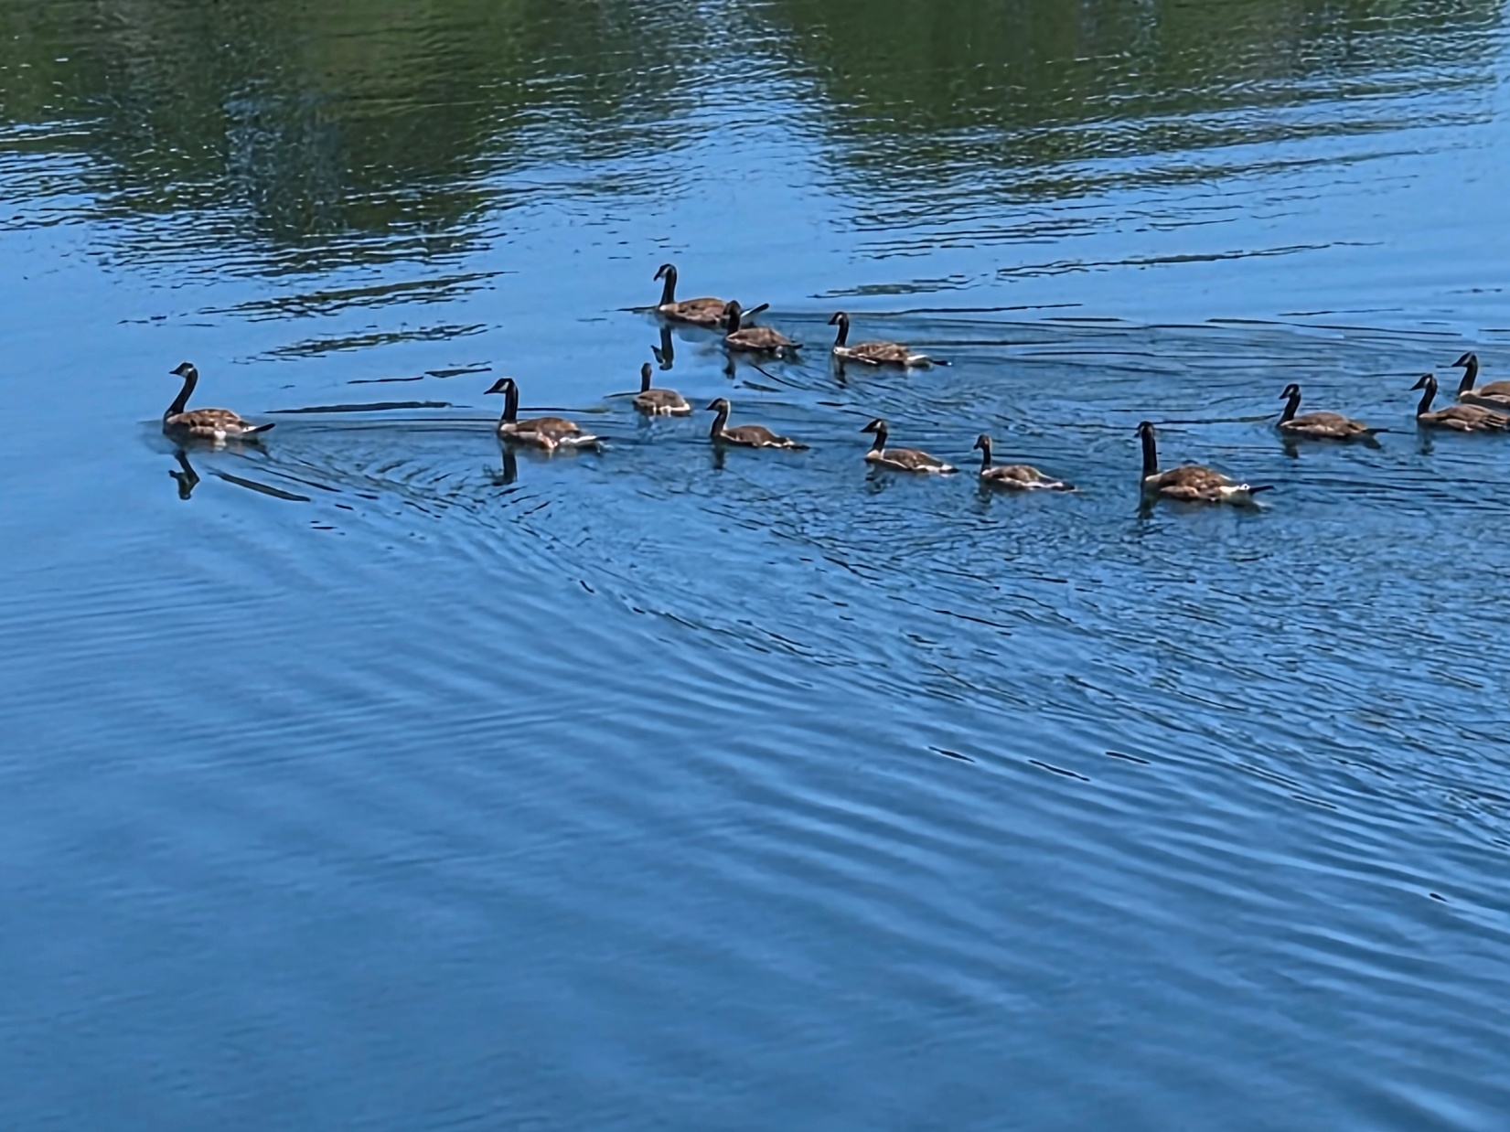
Caption: A flock of Canadian geese swimming in Lake Suttonfield. Photo by: Carmen Vanni, California State Parks.

News & Updates

SDCOS to Host BioBlitz for the First Time Since 2024
Back in 2024, Bay Area District supervisors brainstormed ways to promptly bring interpretation to the newly acquired Sonoma Developmental Center Open Space property. They decided to reach out to the recently promoted State Park Interpreter I Kaylie Williams (who now serves at Trione-Annadel SP, Tomales Bay SP, and Marconi Conference Center SHP) and asked her to host an event. Kaylie brought her creativity and expertise to SDC Open Space by hosting a BioBlitz in September of 2024 with over 140 recorded observations, 75 recorded species, and a crew of 9 observers. You can see the detailed results on the iNaturalist website at California Biodiversity Day 2024: SDC Bioblitz.
State Park Interpreter I (PI) Carmen Vanni is eager to carry on Kaylie’s legacy in the SDC Open Space 2026 BioBlitz. We hope readers decide to visit the park and help record even more species than in 2024. It begs the question: what sort of changes has the park gone through in the last two years? Let’s find out!

SDCOS Staff Build Partnerships at Jack London SHP, Sonoma SHP, and Sugarloaf Ridge SP
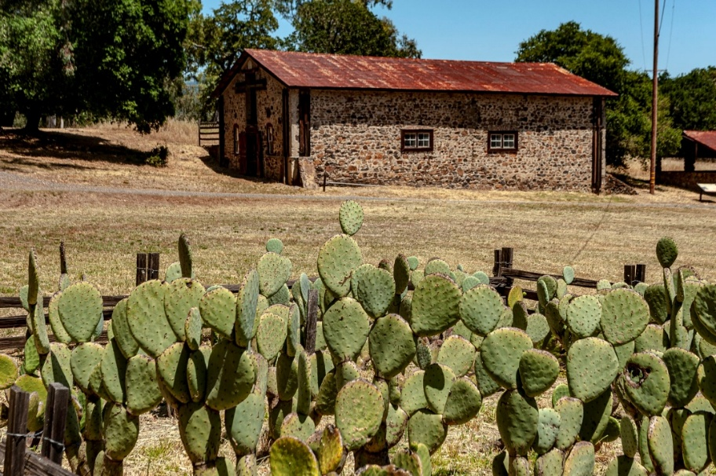
State Park Interpreter I Carmen Vanni attended multiple events at other California State Park locations during the month of August. First was the Nature & Community Fair held on August 8th, 2026 at Sonoma SHP. Lead by Park Interpretive Specialist Dave Duplantier, the event connects various public and nature organizations to the community. Our staff connected visitors to SDC Open Space as well as other Bay Area District parks to visitors of all ages.
Caption: Beauty Ranch at Jack London SHP. Photo by: Brian Baer, California State Parks.
Next, park staff attended two partner park events on Saturday, August 29th: the “Human History Hike” at Sugarloaf Ridge SP at 9 AM and the “Walk on the Wild Side” evening hike at Jack London SHP at 6:30 PM. The Human History Hike was led by a knowledgeable docent who interpreted a wide array of human history, as well as some shared history between the SDC and Sugarloaf. The remains of Camp Butler, a campground used by SDC clients for summer recreation, were once located at Sugarloaf SP. The evening hike at Jack London SHP was led by park staff and interpreted the various nocturnal wildlife commonly seen at the park. Both events were very educational, entertaining, and highly recommended! We will continue to eagerly attend as many partner events as possible (and we recommend that you do too!).

Calendar of Events
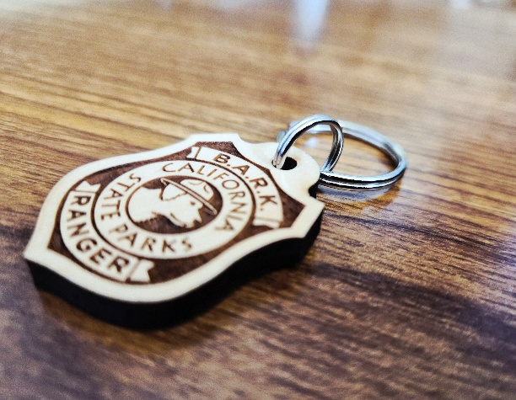

August

Saturday, August 22nd – B.A.R.K. Ranger Pop-Up
Do you love walking your dog at your local state park? Check out our B.A.R.K. Ranger pop-up tent at SDCOS on Sunrise/Baker Road from 9 AM to 12 PM and learn how your pup can become a B.A.R.K. Ranger!

September
Caption: B.A.R.K. Ranger badge. Photo by: Carmen Vanni, California State Parks.

Saturday, September 12th – SDC Open Space BioBlitz 2026
What species call our park home? Let's explore together! Help us develop a species list for our newest property via iNaturalist! Meet at the intersection of Harney and Railroad at 10 AM on Saturday, September 12th and let’s explore Lake Suttonfield together!

Saturday, September 19th – Accessible History Walk
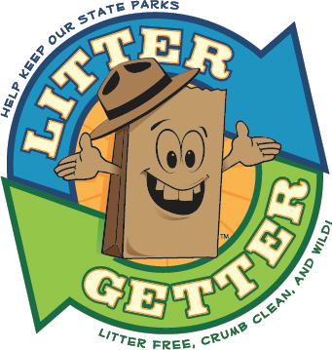
Join us for an accessible history walk and learn about disability history at SDC Open Space. Meet at the intersection of Harney and Railroad in Eldridge, California at 10 AM. Water, hats, and sturdy shoes are recommended. Walk will be on the Sunrise/Baker Loop on the eastern side of the property. The paved path has light shade and gradual changes in elevation. Walk will last for one hour.

October

Saturday, October 10th – SDC Open Space Clean-Up Day
Tired of seeing trash in the park? Come and join us from 10 AM to 12:30 PM for a chance to beautify and protect the SDC Open Space. Meet at the intersection of Harney and Railroad. Gloves, bags, and trash grabbers will be provided. Water, hats, and sturdy shoes are recommended. This event is part of the Litter Getter Program.
CALIFORNIA STATE PARKS SUPPORTS EQUAL ACCESS. PRIOR TO ARRIVAL, VISITORS WITH DISABILITIES WHO NEED ASSISTANCE SHOULD CONTACT CARMEN VANNI AT (707)769-5652.
