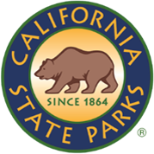
SDC OPEN SPACE

NEWSLETTER

ISSUE NO # 005| SEPTEMBER 2026
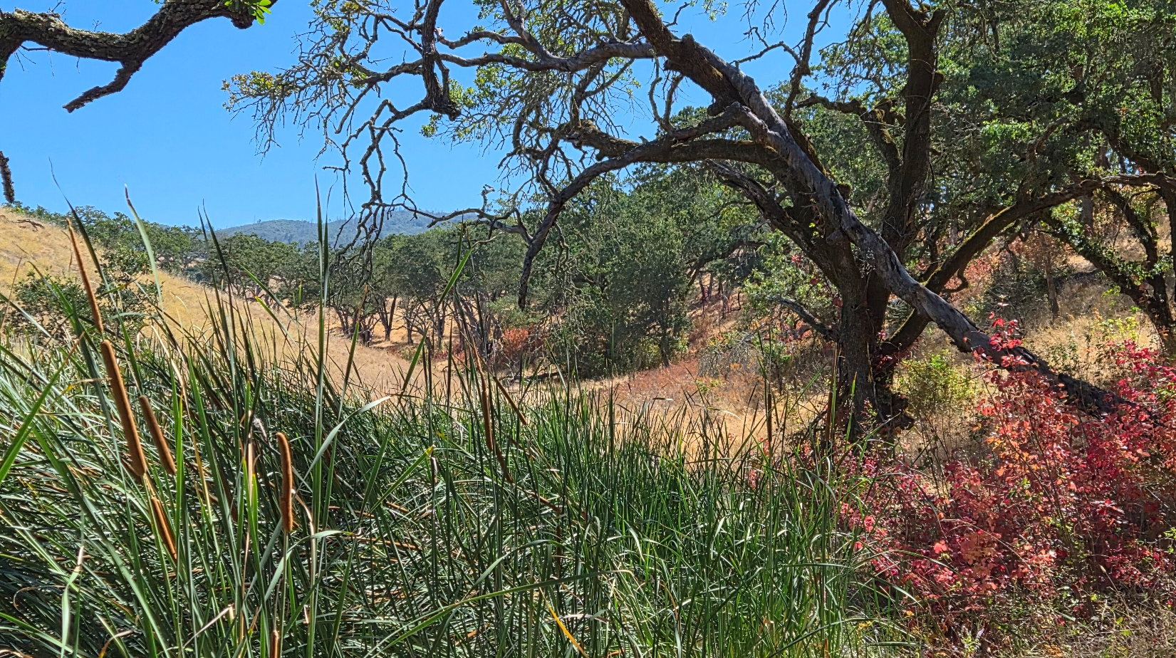
Caption: Various plants near the shore of Lake Suttonfield at SDC Open Space. Photo by: Carmen Vanni, California State Parks.

WELCOME!
You may have noticed that the SDC Open Space Newsletters have received a new look! These changes were applied to reinforce our journey towards accessibility within these documents and in our parklands. Accessibility is a journey that never ends, so don’t be surprised if we change things again! We hope you enjoy this newsletter.
Carmen Vanni (she/her)
State Park Interpreter I (PI)
Carmen.Vanni@parks.ca.gov

TABLE OF CONTENTS

Featured Article: What is Digital Accessibility? 4
What is the Latest News on the Cannabis Watershed Protection Program (CWPP)? 6
News & Updates 6
Calendar of Events 7

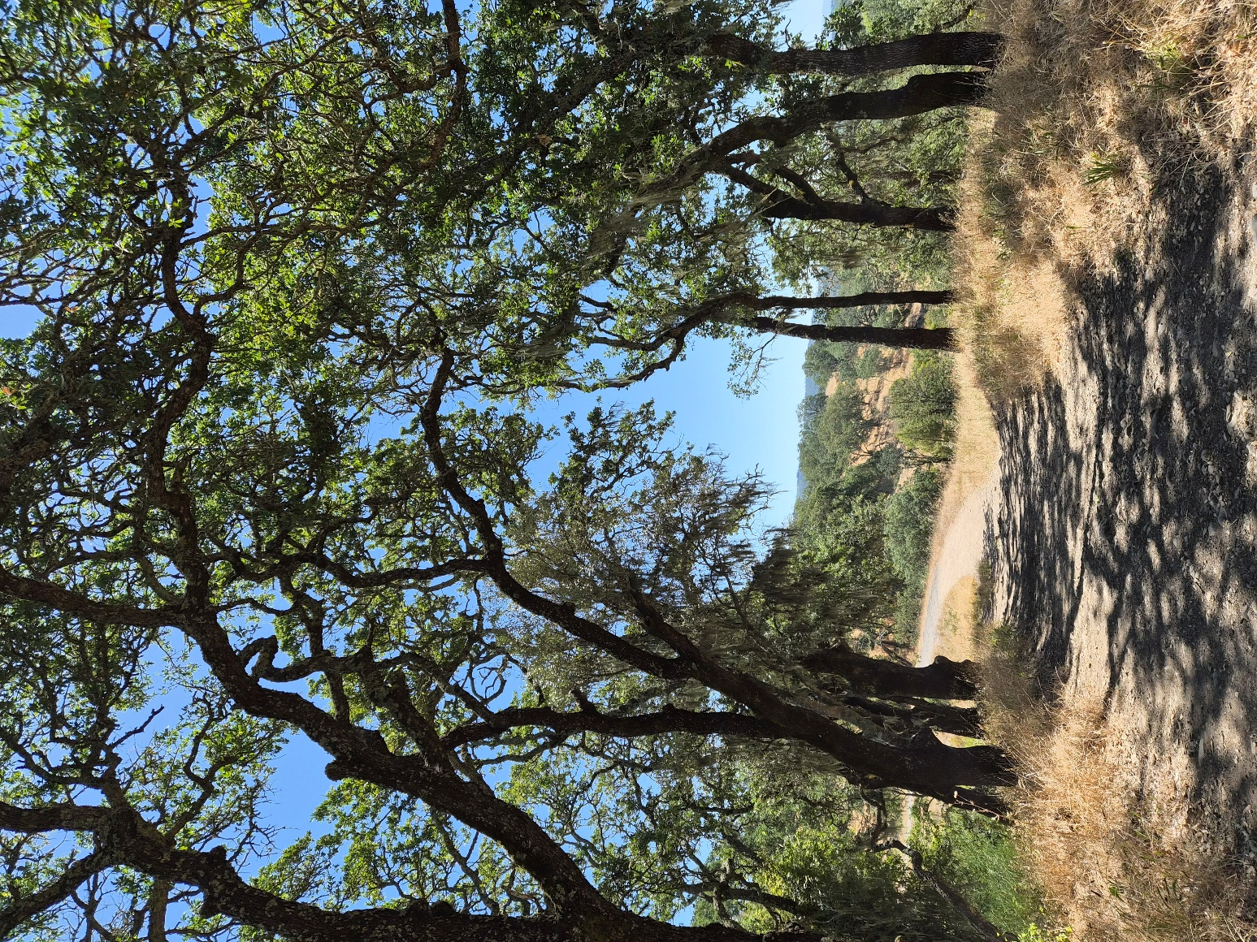
Caption: A shady trail near Lake Suttonfield. Photo by: Carmen Vanni, California State Parks.

Featured Article: What is Document Accessibility?

On Friday, August 14th, an email popped up in my inbox from DPR Web Team Kelly Thorn titled “Site Improve ADA Scan errors on document”. The body of the email explained that the SDC Open Space Newsletters hosted on the website did not meet ADA requirements and are therefore out of compliance. According to Assembly Bill No. 434 (AB 434), California state agencies are required to have all information technology projects hosted on public websites take the necessary steps to achieve certain accessibility standards. In other words, according to Kelly, we can only publish documents that meet these ADA requirements on our public website. My documents did not meet those standards, so they were flagged. But what exactly are these standards? Why is this an issue? What steps can we take to ensure our documents meet these requirements? And how will these techniques appear in our online content?
Caption: A laptop keyboard. Photo by: Carmen Vanni, California State Parks.
The first thing we must acknowledge is that most digital content is primarily visual, with audio considered secondary. If we focus on visual content as an example, we need to first understand how it can be inaccessible to people with certain disabilities or experiences. Perhaps someone is blind and cannot see any visually presented information. Maybe someone has trouble reading text due to dyslexia or dyscalculia. Maybe an image or visual element has a sociocultural significance that is easily lost in translation. Maybe someone is colorblind and cannot tell the differences between certain colored fonts. These are the barriers that we must address every time we bring our services online. Therefore, when creating something like our newsletter, we must consider how our diverse audience can access the information within it.
According to the Department of Rehabilitation, there are seven basic principles for accessibility in digital content:
- Font Style and Size
- Appropriate Use of Color
- Alternative Text
- Headers in Tables
- Meaningful Hyperlinks
- Built-in Styles and Designs
- Accessibility Testing
By following these guidelines, we have an idea of how to make our newsletters accessible.
Let’s revisit the old Newsletter layout. The document was based on a preexisting travel newsletter template within Microsoft Word. The font size was set to 10.5, which is below the recommended minimum of 12. The body font type was thankfully a sans serif font (century gothic) which is easy to read. The two biggest issues with the old newsletters were the table of contents and the lack of tagged headings.
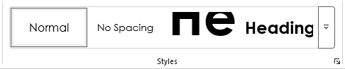
Caption: A screenshot of the ‘Styles’ menu in Microsoft Word.
When creating an accessible document on Microsoft Word, the first thing to implement is the Styles menu. The Styles menu is a feature found in the Home tab where you can label certain text lines in the document. Bodies of text are usually assigned the “normal” style, while section headings are assigned Heading 1, 2, or 3 depending on the hierarchy. For example, heading 1 for this document is “SDC Open Space Newsletter”, heading 2 is both “Issue #005 | SEPTEMBER 2026” and section titles such as “News & Events”.
The reason we do this is because the selected styles create metadata within the document that can be read by a screen reader. If someone using a screen reader does not have this information to refer to, they are forced to listen through the entire document to navigate to the sections they want to see. They cannot “jump” around the document. This also applies to the table of contents. If the table of contents is created without using the designated tool in Microsoft Word, the document doesn’t have the heading locations saved as metadata. Other accessibility elements, such as alternative text descriptions for images and text for hyperlinks, must be present for a screen reader to see it. This metadata can also be preserved when saved as a different file type, such as a PDF.
The last step is to make sure the PDF version of the document is accessible. This step requires the use of “tagging” sections of the document. Adobe Acrobat Pro accounts can highlight and “tag” segments of text with metadata, as well as rearrange the order of which tags are read on a screen reader. It is always good to double check that the metadata transferred correctly. Once that is done, the PDF can be scanned by a screen reader software for one last final check before being posted on the state park website.

If you have any questions, comments, anecdotes, or suggestions about accessibility regarding SDCOS park land, programming, or communications, please contact us via email at Carmen.Vanni@parks.ca.gov or call the Bay Area District Office at (707)769-5652 | 711, TTY Relay Service.

What is the Latest News on the Cannabis Watershed Protection Program (CWPP)?
Bay Area District staff met on Wednesday, September 2nd to review a draft proposal document of the CWPP interpretive panel project. After some deliberation, the team decided to revisit SDC Open Space on Friday, September 11th to confirm the installation locations for five interpretive panels. The document has been updated with GPS coordinates and images of the proposed panel locations.

News & Updates

Bay Area District Supervisors Create Accessibility Coordinator Team
Bay Area District Superintendent II Maria Mowrey and Deputy District Superintendent (Acting) Cara O’Brian appointed four Bay Area District employees to the Accessibility Coordinator Team on Friday, August 14th. The role is responsible for fielding accessibility complaints and managing accessibility projects across the district. The four members of the Bay Area District Accessibility Team are:
- Andrew Padilla – Park Interpretive Specialist (Angel Island SP)
- Destin Koelsch – Park Maintenance Worker I (Angel Island SP)
- Cecilia Rejas – State Park Peace Officer (Bay Area District)
- Carmen Vanni – State Park Interpreter I (PI) (SDC Open Space)
Each member brings their own experience, skills, and dedication to the accessibility team. These skills include interpretive programming, digital accessibility, accessible facilities, sensitivity training, and community building.

Monday, September 21st is California Memorial Project Remembrance Day

Disability Rights California held its 24th annual California Memorial Project Remembrance Ceremony on Monday, September 21st. The ceremony served as an opportunity for members of the community to gather and remember individuals who lived and died at state institutions. The ceremony theme for this year is “Honor. Reflection. Hope” which is symbolized by the cherry blossom. Ceremonies were hosted both virtually and in-person.
SDC Open Space staff attended a private ceremony in Napa on Monday the 21st. Many of the event organizers were aware of the history of the Sonoma Developmental Center and welcomed the district’s representation for this beautiful event. A recording of the virtual event can be found here.
Caption: An enamel cherry blossom pin distributed at the ceremony. Photo by: Carmen Vanni, California State Parks.

Calendar of Events
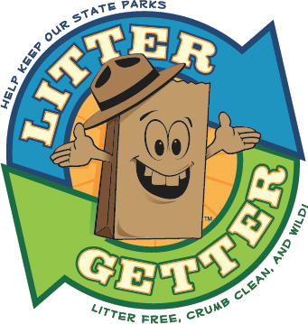

October

Saturday, October 10th – SDC Open Space Clean-Up Day
Tired of seeing trash in the park? Come and join us from 10 AM to 12:30 PM for a chance to beautify and protect the SDC Open Space. Meet at the intersection of Harney and Railroad. Gloves, bags, and trash grabbers will be provided. Water, hats, and sturdy shoes are recommended. This event is part of the Litter Getter Program.

Saturday, October 24th – Lake Suttonfield Guided Hike
Check out the new Sonoma Developmental Center Open Space with a State Park Interpreter by hiking around the beautiful Lake Suttonfield! Meet at the intersection of Harney and Railroad in Eldridge, California at 9 AM. Water, hats, and sturdy shoes are recommended. This easy to moderate hike is about 2.5 miles in length on unpaved trail with slight elevation changes. Hike is expected to last at least 1.5 hours. Park does not charge for entry.

Saturday, October 31st – Halloween Costume B.A.R.K. Ranger Pop-Up
Do you have an amazing costume for your dog this Halloween? Do you love walking with your dog at your local state park? Check out our B.A.R.K. Ranger pop-up tent at Sonoma Developmental Center Open Space on Saturday, October 31st from 9 AM to 12 PM and learn how your pup can become a real B.A.R.K. Ranger! This is a self-guided activity with prizes available upon completion. Halloween-themed prizes are also available for dogs in costume. Meet us near the intersection of Sunrise and Baker Road on the eastern side of the property and look for a CA State Parks pop-up tent and table. B.A.R.K. Ranger paraphernalia available until supplies last. Park does not charge for entry. Public parking is available along Harney Road. Please park and walk past the eastern metal gate to reach Sunrise Road.
For more information about dogs in parks, go to the "Visiting State Parks with Dogs" page here: https://www.parks.ca.gov/dogs.

CALIFORNIA STATE PARKS SUPPORTS EQUAL ACCESS. PRIOR TO ARRIVAL, VISITORS WITH DISABILITIES WHO NEED ASSISTANCE SHOULD CONTACT CARMEN VANNI AT (707)769-5652.
